Name: _______________________________________

Student Tutorial

Create a computer program in Python

Python IDE’s

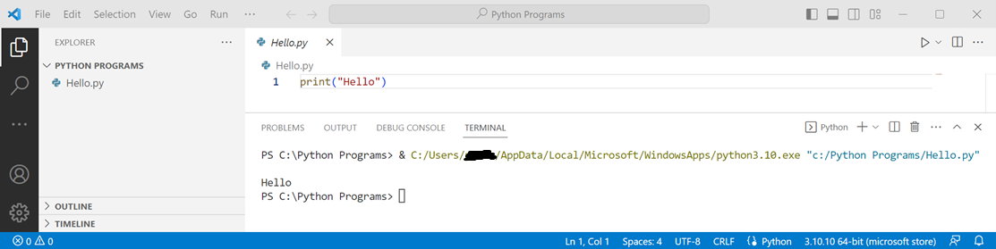
Your teacher will show you how to access your IDE and guide you about where programs are to be saved

Using print

Introduction
Print is exactly as you would expect - it is used to put output into the terminal window
Python likes to keep it simple. You always use lower case for any function name
Explanation
A “function name” is any of pythons built in commands like “print”, “input” etc.

Syntax
The basic syntax of print is print() with what you want to print in the brackets


Formatting
Python like most programming languages includes many very old methods of formatting. Because Python is text based no better or easier methods have been developed
You can create GUIs (Graphical User Interfaces) with Python. We will do that next year
\n will add a new line. It can be placed anywhere in the text
\t will add a tab. This is the same as pushing the tab key. It is different to pushing space a number of times
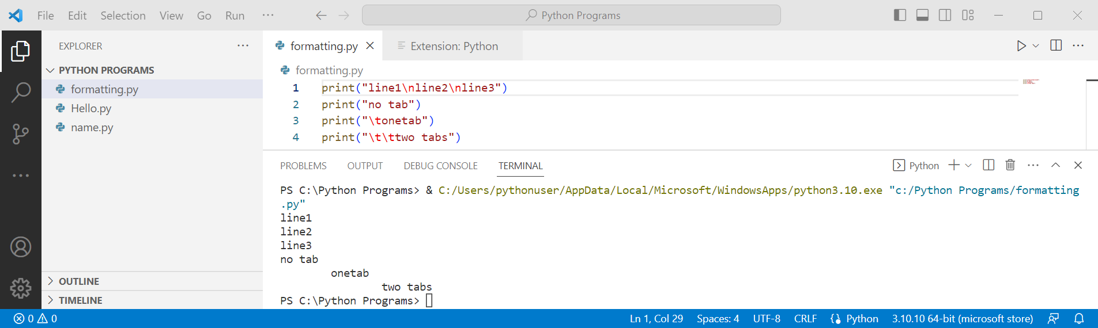
Try for yourself:

Working with variables

Allowed characters
Python allows you to use any text character, number and underscore _ to name a variable
However, variables must always start with a text character - below is the complete list
abcdefghijklmnopqrstuvwxyzABCDEFGHIJKLMNOPQRSTUVWXYZ1234567890_
You will notice that the alphabet is repeated twice with both lower case and uppercase characters. This is because an upper and lower-case character is stored by the computer as different Unicode numbers

Naming variables
We could start at the beginning of a program and name the first variable “a”, the next “b” etc. However, this would make the program very hard to understand
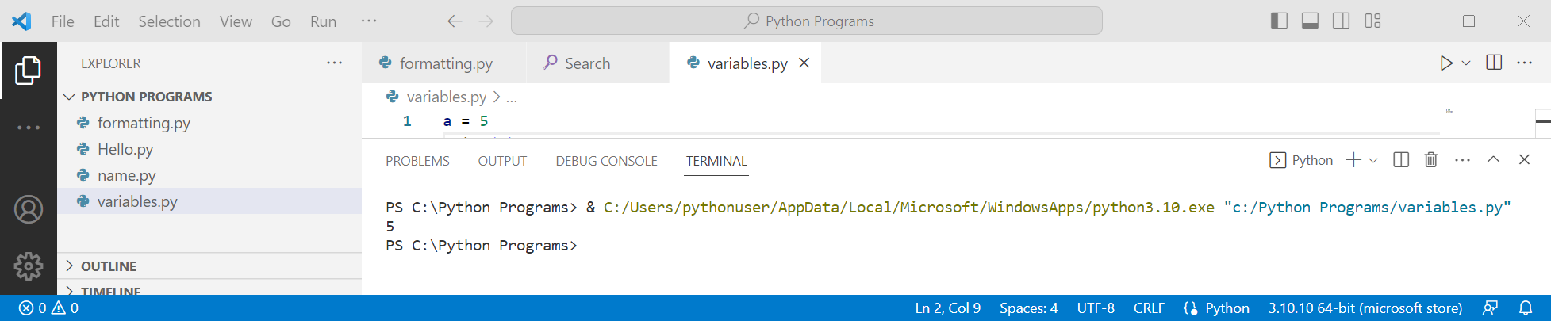
Instead we should name a variable with what it contains. Just like we would name a box that contains shoes “shoes” not “a”

Python naming conventions
There are many ways to name variables. Only one of them is acceptable by NZQA as it is the agreed standard naming convention for Python
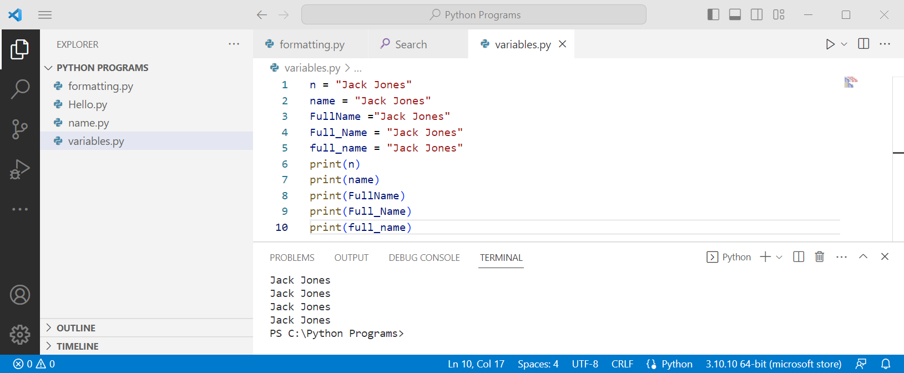
You can see that the program works with each variable, but only the last one is acceptable
It all makes good sense - mixing upper and lower case can lead to confusion. By only using lower case you always know. You can see below that you can’t create the variable in lower case, then print using upper case
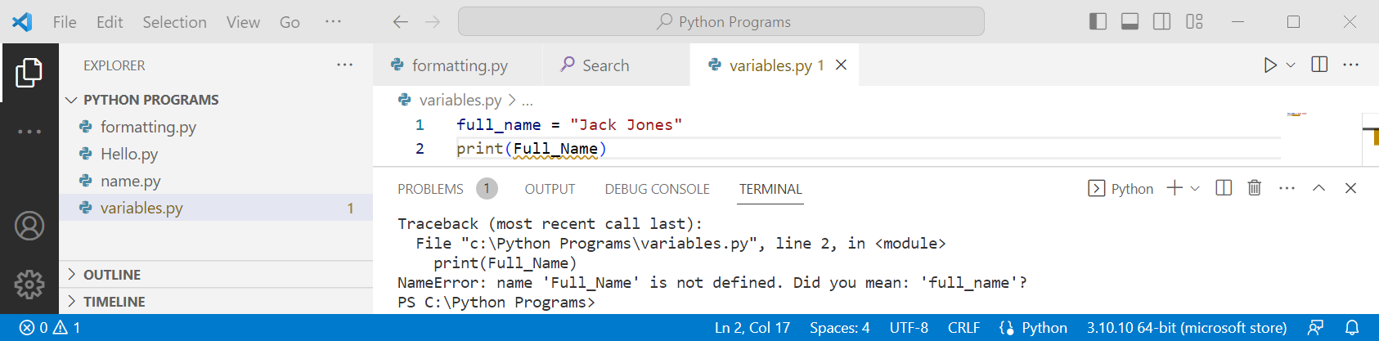
Python naming convention also requires that two words are always joined together with an underscore. Even if you think one word would do like “age” you need to use two words like “current_age”. At times this may not even seem to make sense. Just remember that is not a choice - it just has to be done

Python naming conventions – Constants
All rules have exceptions and Python is no exception. The one we will cover here is constants
A constant is a variable that is set in the program and does not change. These are two examples
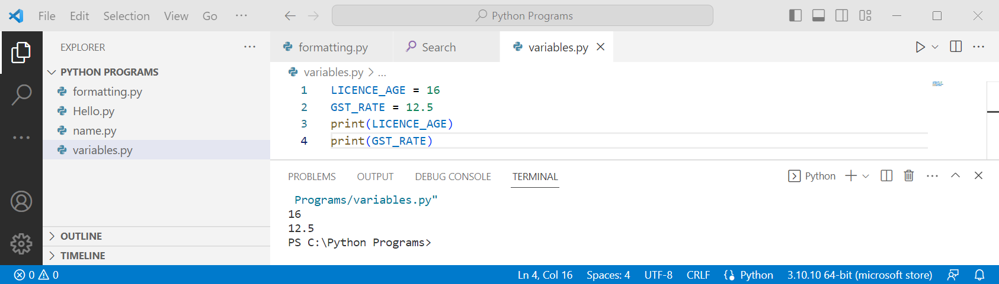
If you look at the examples of constants above you can see that they could potentially change. For example, the drivers licence age in New Zealand was 15 until 2011 when it was raised to 16
It is also good programming practice to put constants at the start of the program
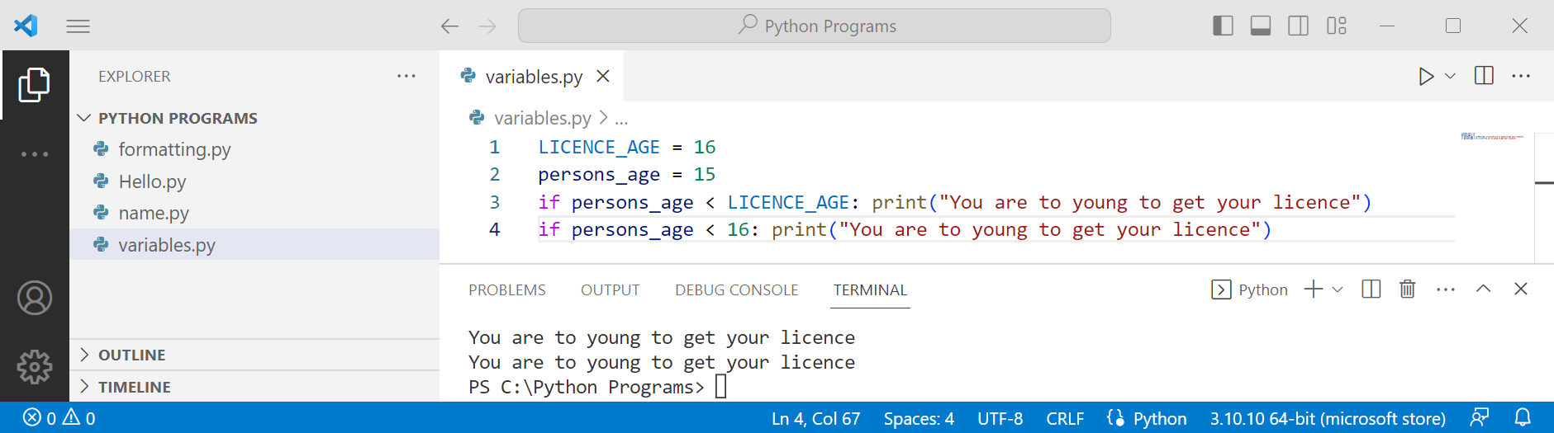
It may look like simply putting in the age is easier, however, with longer more complex programs where the licence age is referred to many times, it makes it much easier to update the program should a change occur
While most of the programs you write will never be used again, as a beginner programmer you need to learn good habits from the start, not trying to correct bad habits later

Task time
We have used only one variable for the name, separate it into two parts
Create a variable for where people live
Create a constant for when people can stop working at 65
Write a program for all three of these and print the result

Combining print and variables
We can use print to just print text by putting it in quotes, or we can just print variables, or you can print both
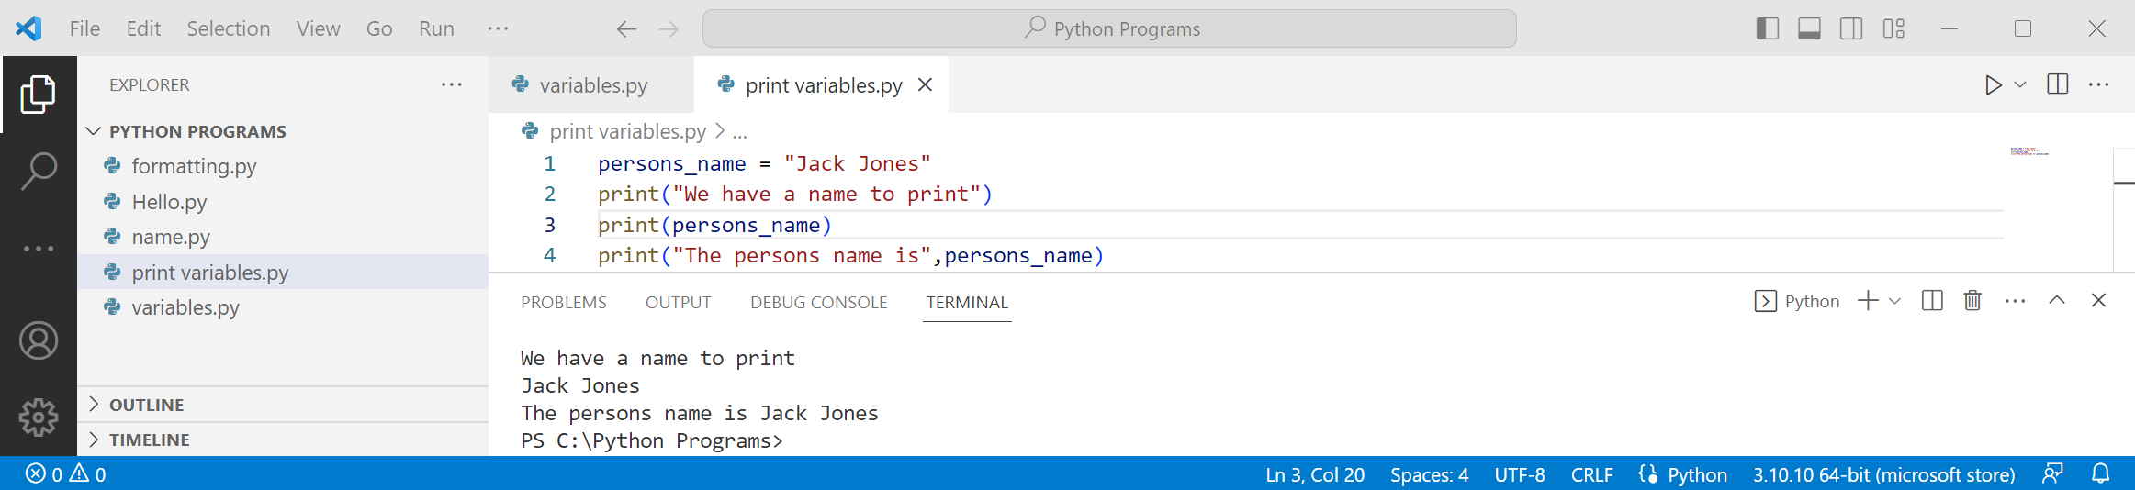
Note the use of a comma to separate the text from the variable - there are other ways to do it
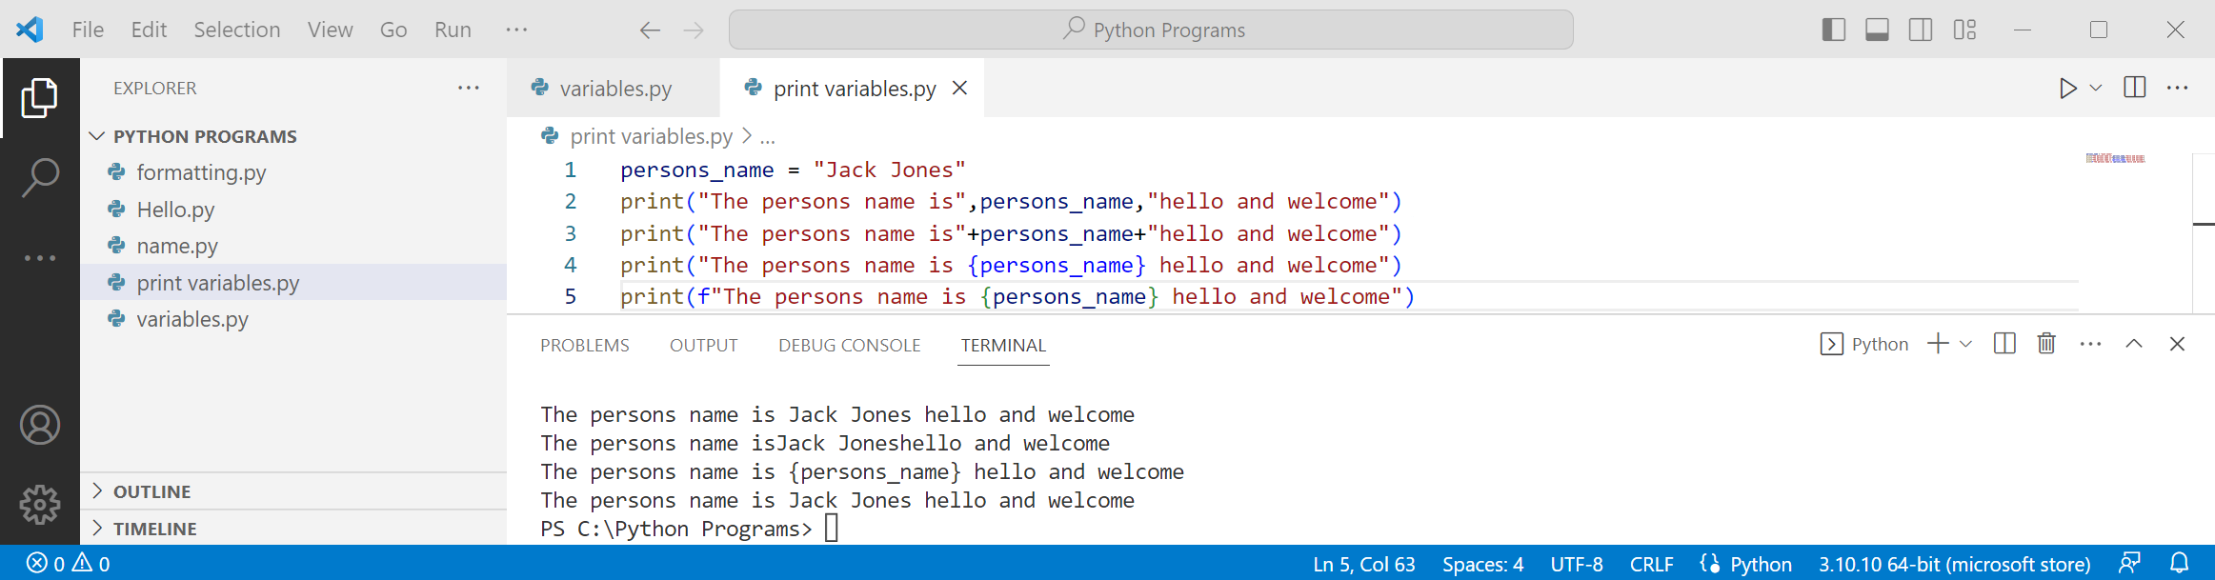

Having the comma adds a space for you automatically but the plus does not. There are times when either option might be better, for example, if you want to use the dollar sign you need the plus
Using f lets you combine variables and text with the quotes using braces {} to show where the variables are. This way you add any spaces or other formatting yourself
f is a powerful feature in Python to format - we have only used the most basic part of it
Solution to task
We have used only one variable for the name, separate it into two parts
Create a variable for where people live
Create a constant for when people can stop working at 65
Write a program for all four of these and print the result
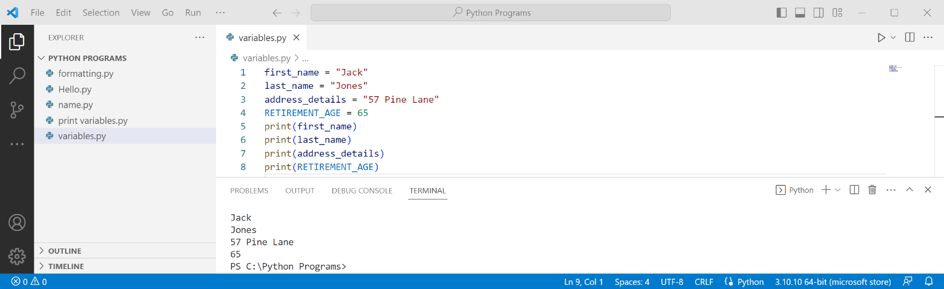

Task time
Create a program contains variables for:
- name in two parts
- where they live in three parts
- two different ways to contact them
print the details

Doing some maths

Introduction
Computers and programming languages are very efficient at doing maths. They just do it a little bit different to how we are used to. This is partly due to most maths symbols on the keyboard also being used for other things
The basic operators plus, minus, divide and multiply on the keyboard are + - / * . Once you get used to them they will just look like the symbols to you
For an exponent such as 2⁵ we used 2**5. This is the same as 2*2*2*2*2 or 32
Task time
Create two variables for two numbers and give them each a value
Calculate into separate variables the numbers added, subtracted, multiplied, divided and their exponent
Print well formatted text to indicate each calculation

Paste your screenshot here:

Solution to task
Create two variables for two numbers and give them each a value
Calculate into separate variables the numbers added, subtracted, multiplied, divided and their exponent
Print well formatted text to indicate each calculation
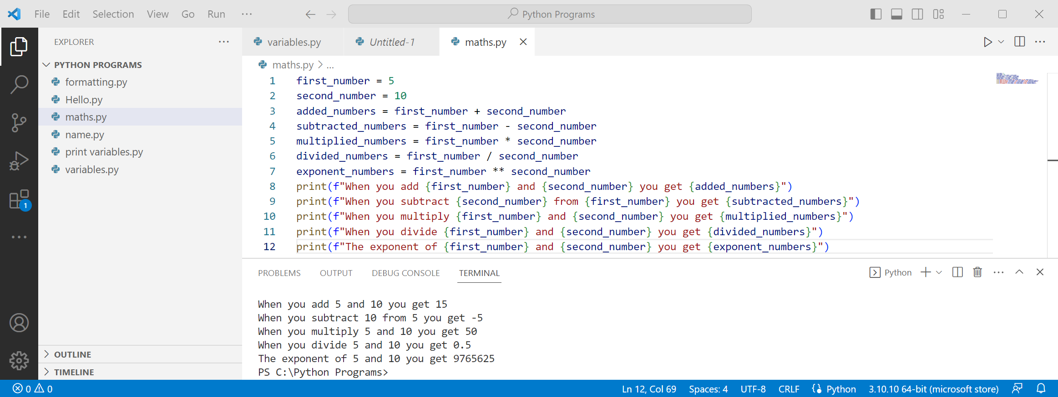
If you did not correctly format your program go back and make some changes. It does not need to be exactly the same as shown

Getting some input

The input statement

Input example – using a variable
We can first create a variable and then use that variable in the input statement
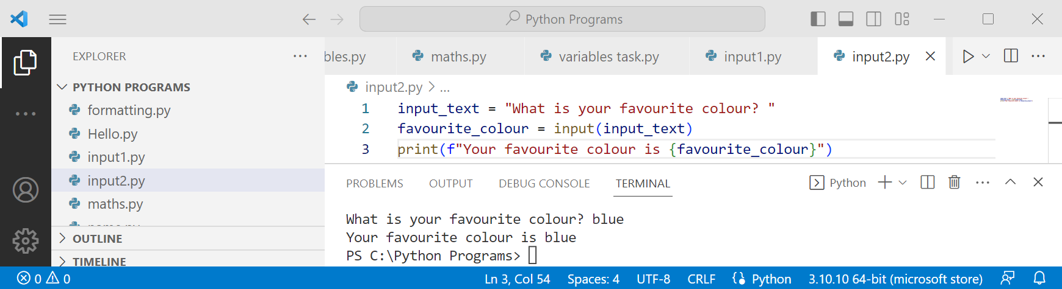
At this stage it seems rather pointless doing it this way, and generally that is true!

Complex input statements
We can create a complex input statement by using plus to combine variables and text
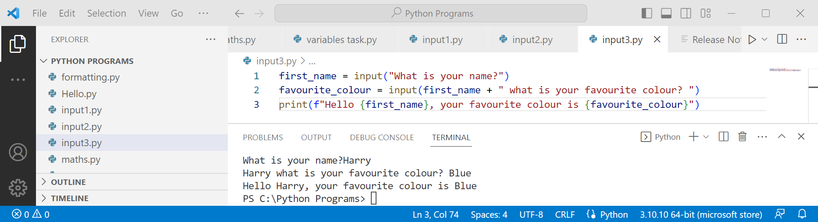
You can only use the plus symbol - comma does not work and will give an error
If you are using an old version of Python this may not work
Solution to task
Improve the program so the input statement asks a suitable question
Below are a range of possibilities, each one is better
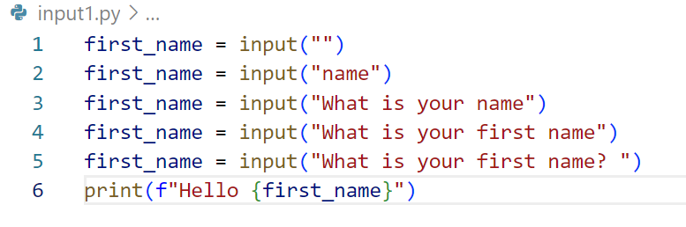
- The original program
- Asking for the name, unclear exactly what is asked for. Lower case n in name is poor
- Good to have a sentence but still unclear what is asked for
- Clear what is needed, but not well formatted where the name is typed in
- Well written with a question mark and a space
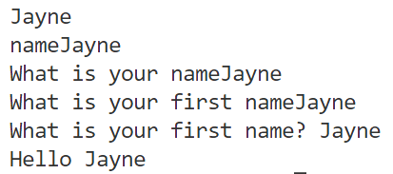

Multiple inputs
It is questionable if this is needed, but we are covering for completeness.
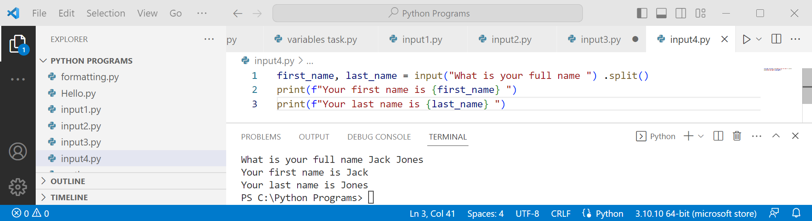

About .split()
Split is used to split a string into more than one part
By default it splits on the space character - we can put something else in the quotes
Task time
Modify the program to also ask for the age
Change the split so it uses a comma instead of a space
Change first name so it asks for both first names. For example the input could be Jack James, Jones, 15

Solution to the task
Modify the program to also ask for the age
Change the split so it uses a comma instead of a space
Change first name so it asks for both first names. For example the input could be Jack James, Jones, 15
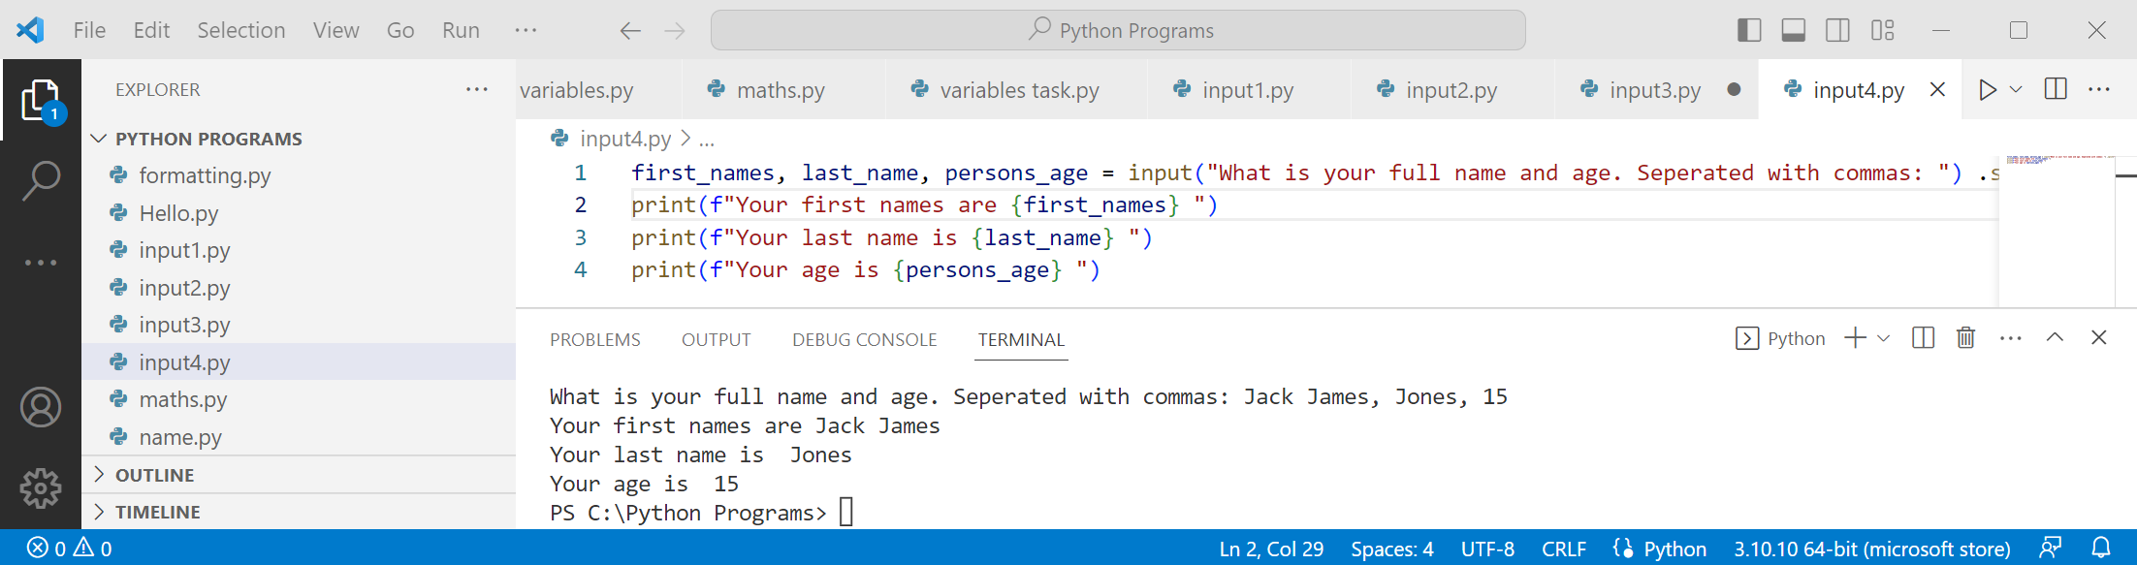

Strings and integers

Example program
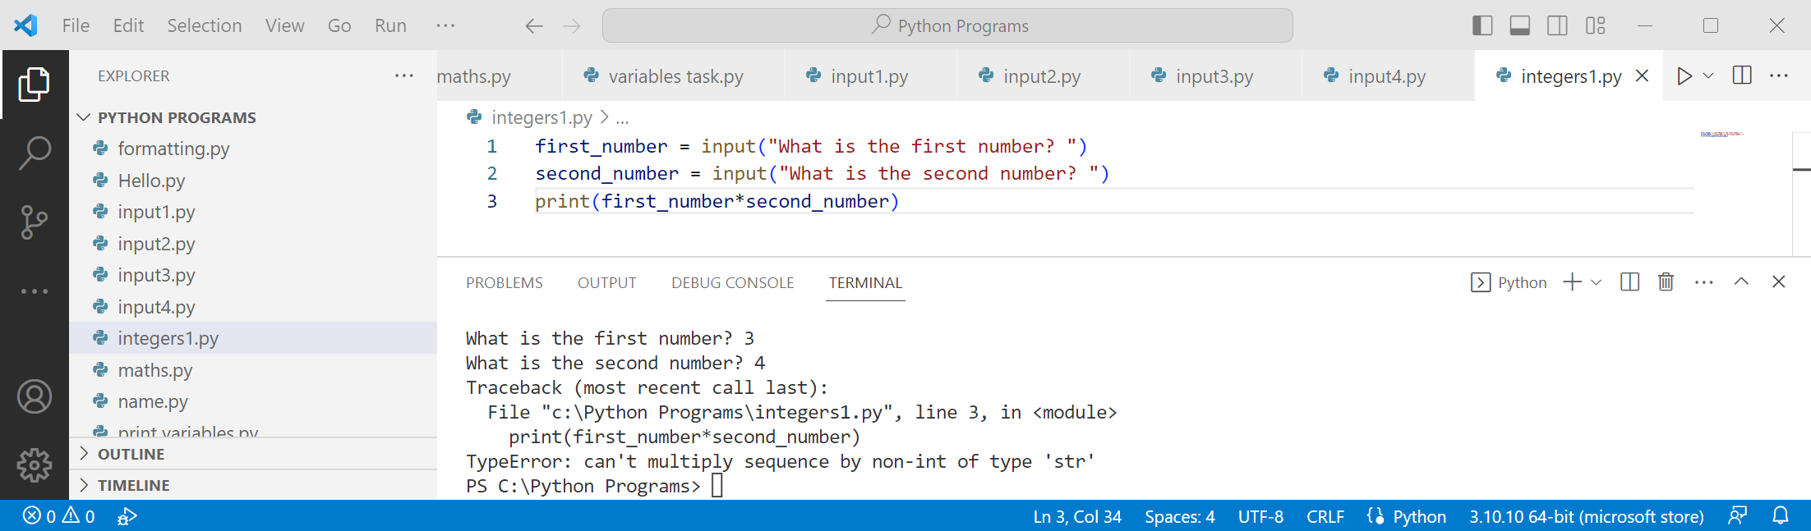
This simple program fails as variables are strings unless the coding indicates otherwise
Add the extra line to the program and check the result
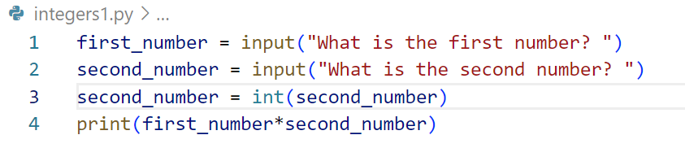

Mixing strings and integers
As said before mixing strings and integers is normal
Task time
Run the program, but this time put in banana for one input and 5 for the other
Try it with banana and 5 the other way around

Getting banana 5 times makes some sense as you asked for 5 bananas. You were given exactly what you asked for
However, if you put in 5 and 7 you get 5555555 not 35 that you would expect
Task time
Change the program so both variables are converted to integers
Try it with 5 and 7
Try it with banana and 5

Saving space by combining code
Instead of taking two lines, the first to input and the second to convert to an integer we can combine
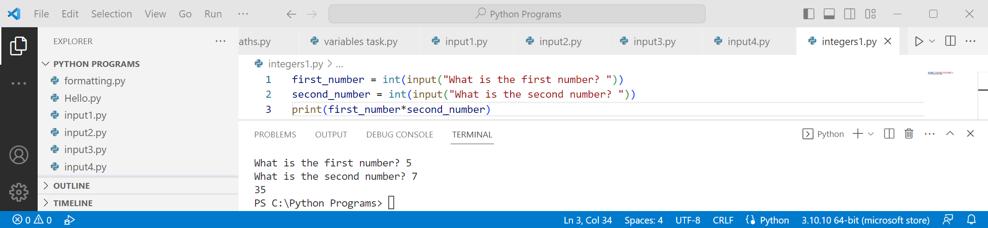

Making use of the while loop

About while
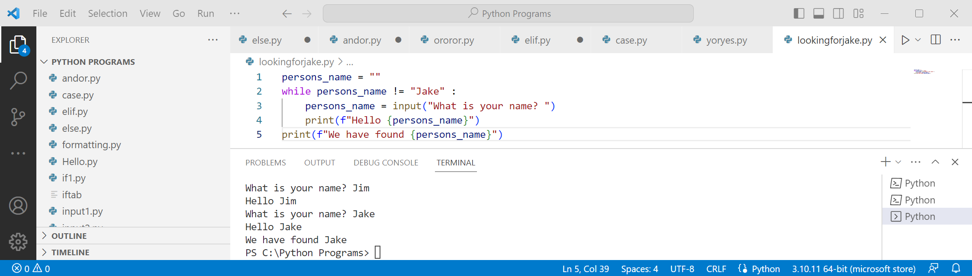
Task time
Improve the program so it only says “Hello” if the person’s name is not Jake

Creating a variable first
The first line of the program is persons_name = “”
This is creating the variable and giving it a value. Using “” sets it to an empty variable
In this case anything except for Jake would have worked just as well
If you are working with numbers you need to set it to a number that does not meet the while criteria
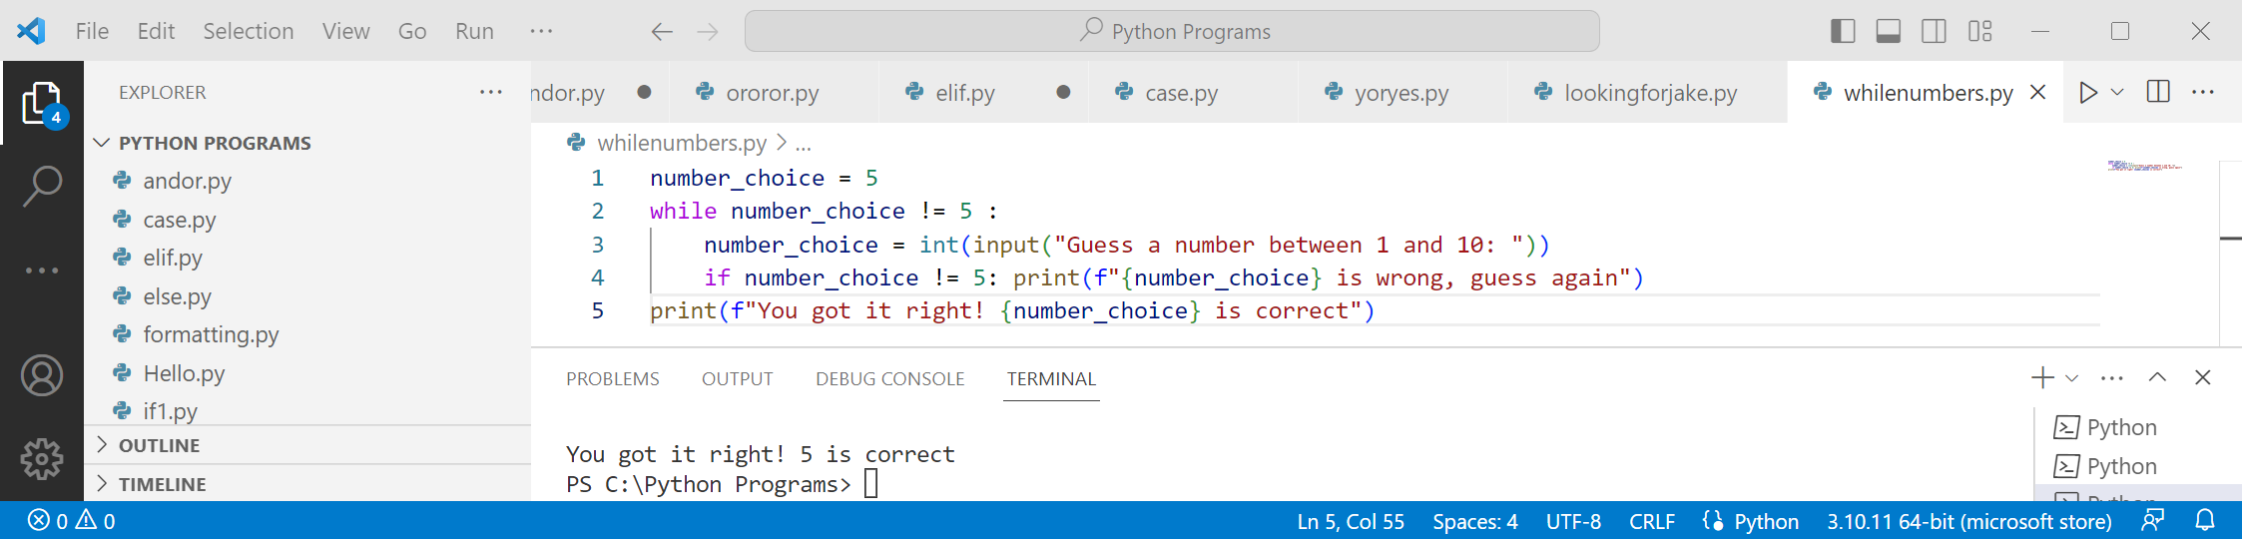

Task time
Fix the program so it can ask the input statement

Solution to the task
Improve the program so it only says “Hello” if the persons name is not Jake
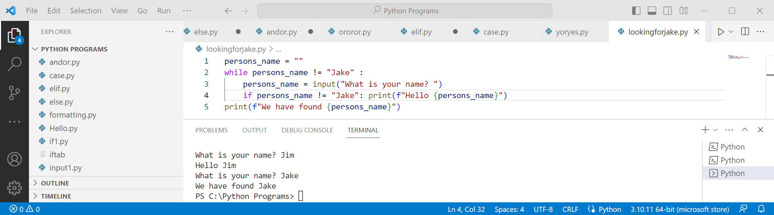

A loop with no input
There are times when you just want to do something a number of times - we can use a counter
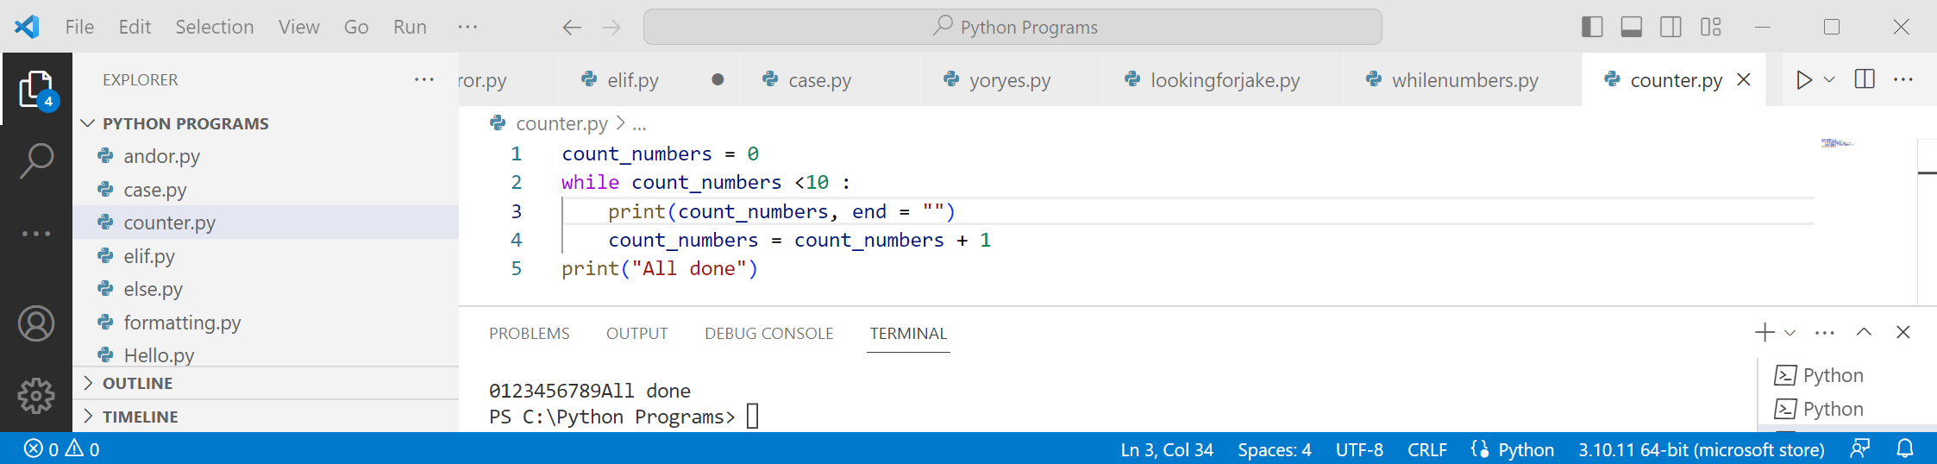
Note the use of end = “”, This stops the new line after each print
Task time
Change the program to have end=”,” instead
No solution given this time

Solution to the task
Fix the program so it can ask the input statement
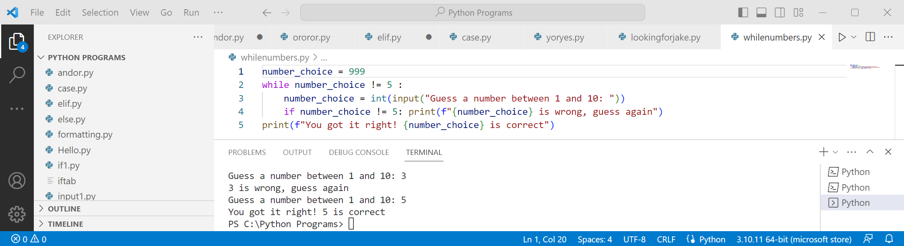
Making the number in line 1 anything except 5 will work
It is good coding practice not to use a number in the range asked for
If we changed it to 7 and then made the correct guess to 7 the program would be broken again
You must put in a number - “” or any other text would make the program fail
This program could be extended by saying “too low” or “too high”

Task time
The last program counted from 0 to 9. Change it to go from 1 to 10 instead
Work out a completely different method to make it count from 1 to 10

Stopping blank entries
Previously we wrote a program that was looking for the name to be Jake
We can instead use a loop to ensure any text has been entered
It prevents people from hitting enter when you want an input
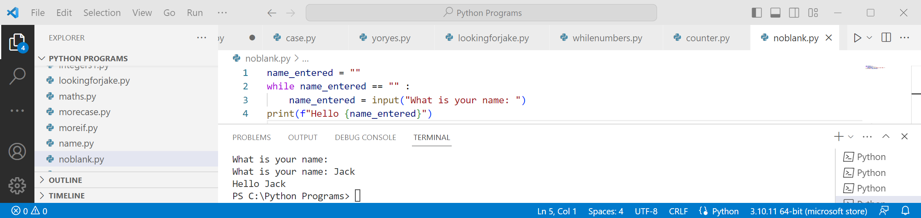
An alternate method is to check the length of the text entered
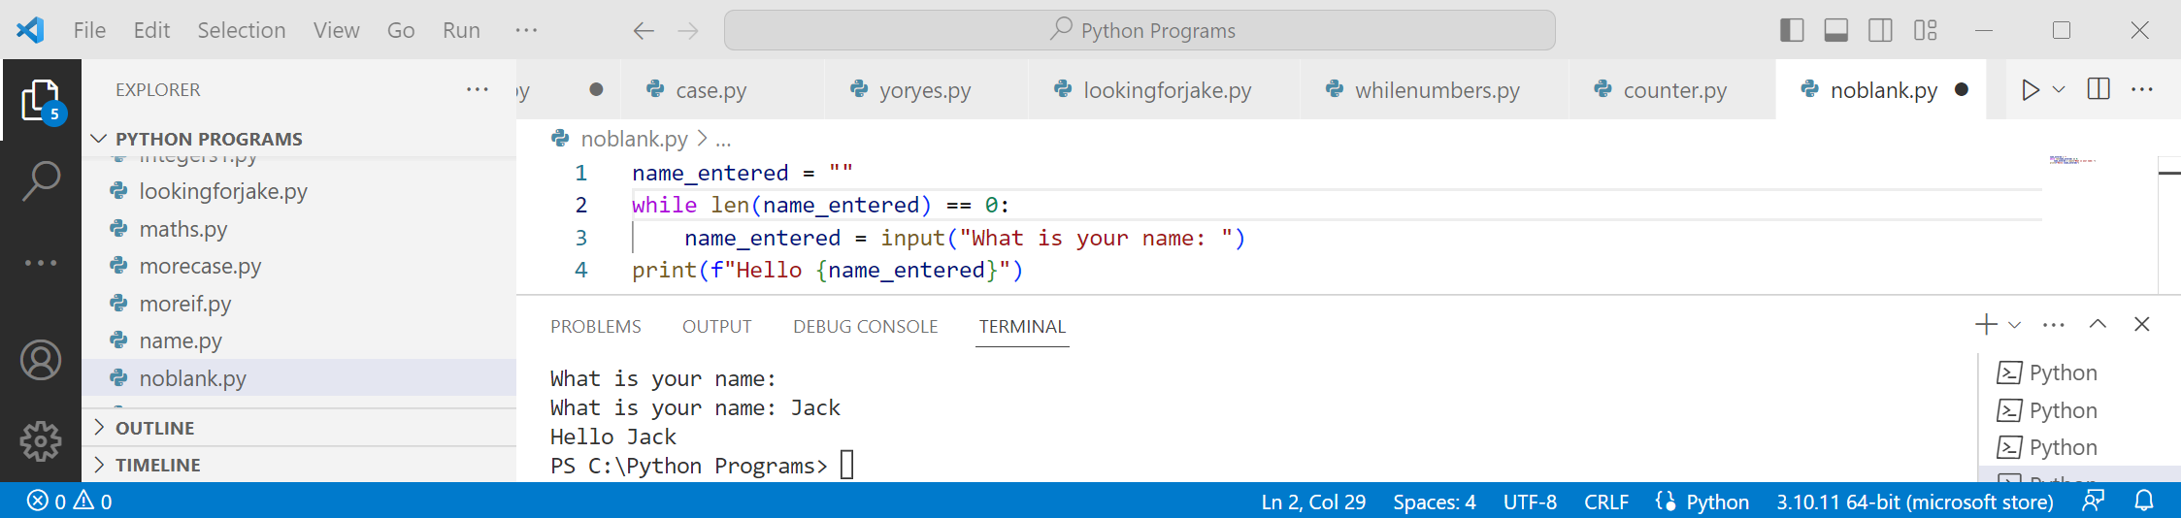
The second method is better when you are asking for a number
However, it does not check the input is a number
Solution to the task
The last program counted from 0 to 9. Change it to go from 1 to 10 instead
Work out a completely different method to make it count from 1 to 10
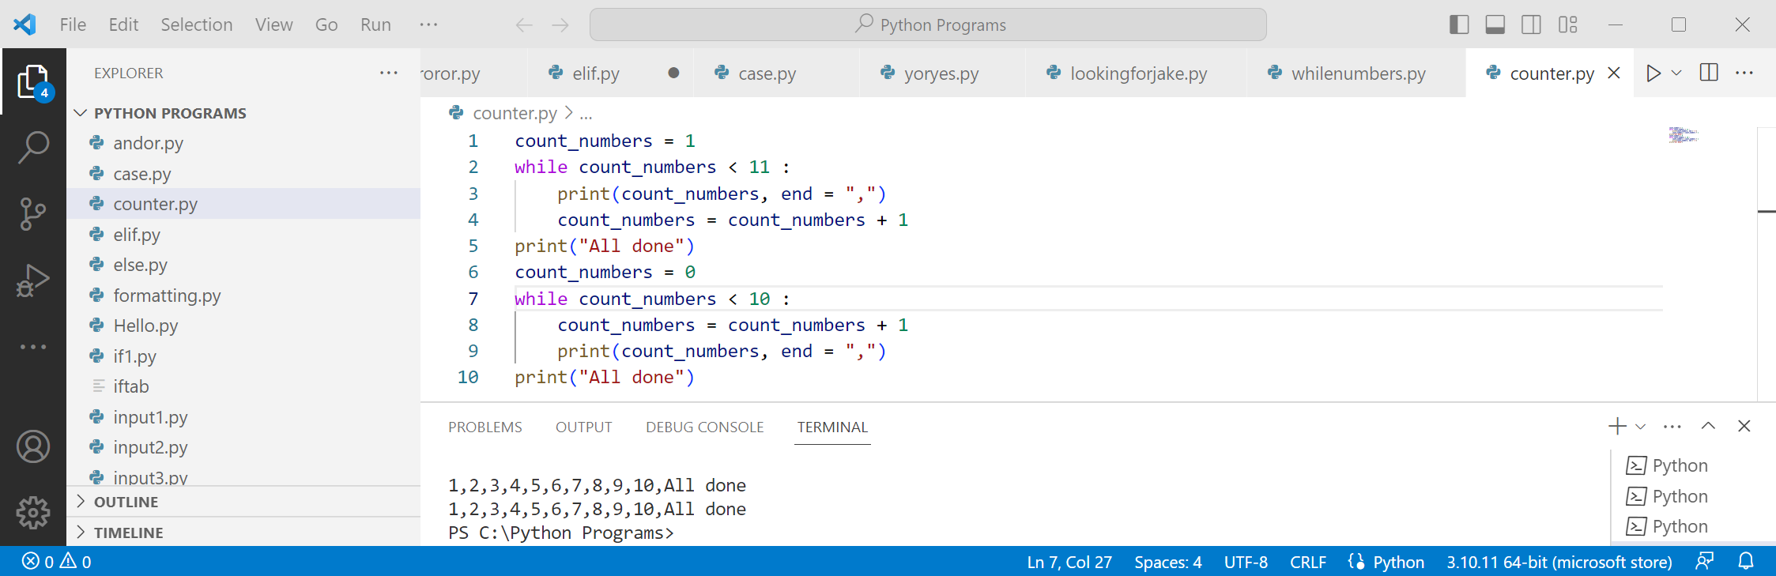
In the first program the start and end number are changed so the numbers go from 1 to 10
In the second program the print and count lines are swapped instead
There are many other methods of achieving this. If you used another it is just as good!

Checking for a number input
We can use .isdigit() to test if a variable is a number or not
It returns either True or False
Unlike most IF statements we don’t use quotes for True or False. If you did it would not work
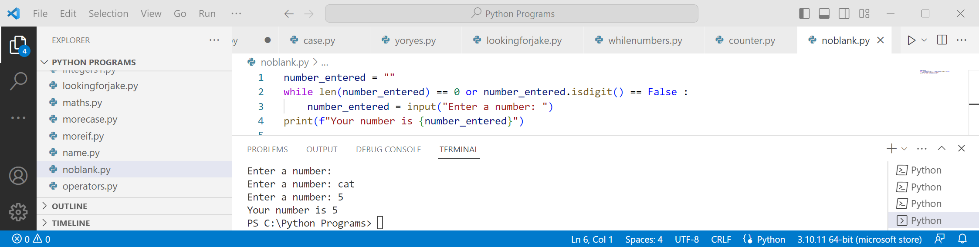
Task time
Modify the program so when a wrong input is entered it asks you to try again
Give a different answer if a blank or text is entered

There are other ways to check the input is a number such as try/except/else
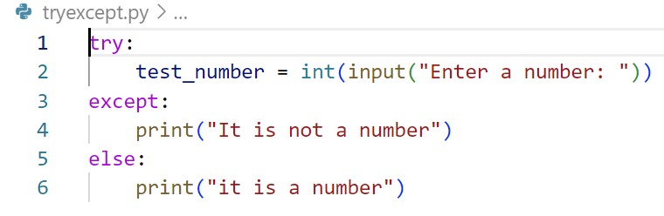
We can use try/except/else to trap a failure in the program
Except is short for exception, which is another way of saying failure. We use it to deliberately find errors
Unless there is a good reason to use it this is considered poor programming. It can be useful for tracing errors
Solution to the task
Modify the program so when a wrong input is entered it asks you to try again
Give a different answer if a blank or text is entered
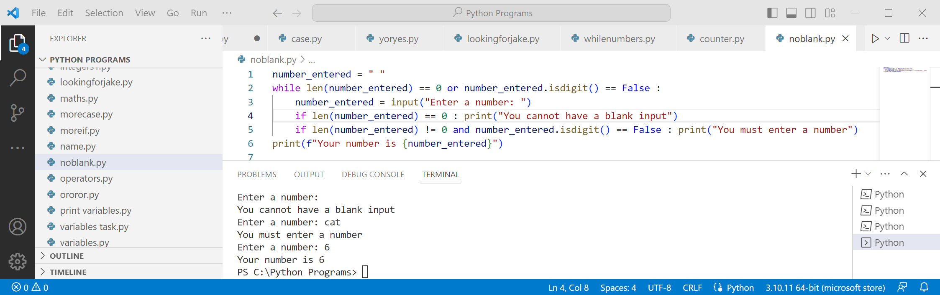
Like many tasks there are multiple ways to do it
This could be written better if an else or elif was used. If you did, you wrote a superior program

Task time
Write a program that asks for a person’s name and age
Check both the inputs are valid
Print off the name and age in a single well formatted statement

Task time
Write a program that asks for two numbers
Print all the numbers between the first and last number
Check both the inputs are valid

Uses of while
We have looked at while and it is a very powerful part of Python
These are the uses we have looked at

Doing something a number of times
Often involves setting a counter and looping that number of times

Checking for valid input
Having an input statement then checking the input is valid
If the input is not valid we loop and ask for it again

Waiting for the correct response
This is very similar to the previous example, but we want to get a certain input
This could be where we ask the person to guess for a number between 1 and 10

Solution to the task
Write a program that asks for a person’s name and age
Check both the inputs are valid
Print off the name and age in a single well formatted statement
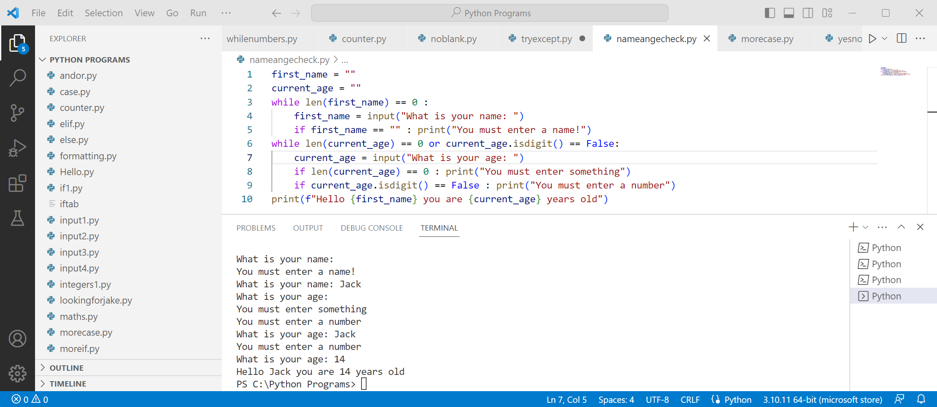

Solution to the task
Write a program that asks for two numbers
Print all the numbers between the first and last number
Check both the inputs are valid
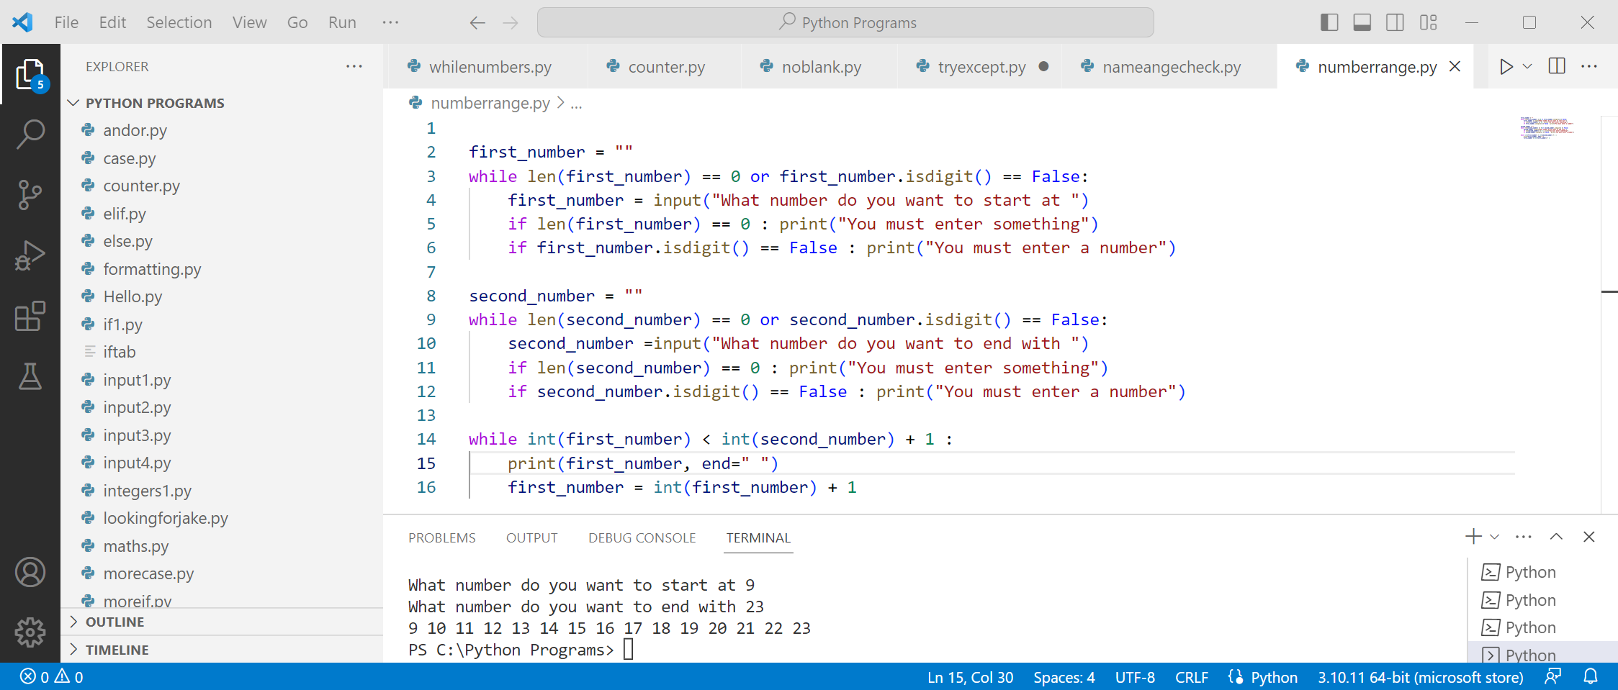
You probably found when you wrote this it took a bit of trial and error to get the correct numbers
This is a part of how all programmers write

Making a list

List overview
So far variables have only contained one value - there is much more to variables than this
The first other way we can use variables are lists
With a list, a variable can store as may values as we wish - we can then access them any way we wish
To store values in a list we use square brackets with the items separated with commas

First list
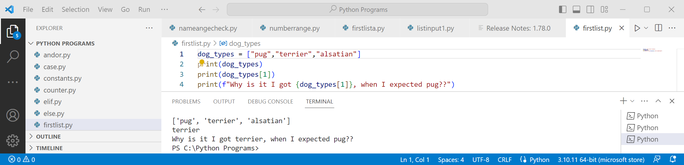
You can see in the above program the use of square brackets
You can print off the entire list or selected items
The program asks why item 1 is “terrier” not “pug”. That is because lists start at 0
Task time
Modify the program so it prints the first item of the list
Change the text so it makes sense after this change

Input statements and lists
The input statement can be used with list to print a selected item
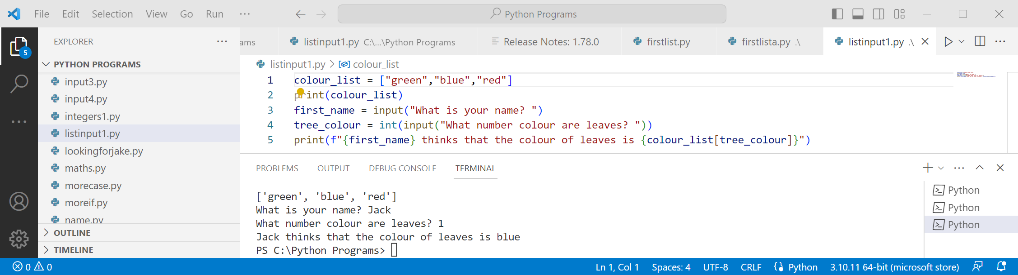

While this program works, it has many issues
Printing off the list is neither attractive nor informative
Task time
Modify the program so each item of the list is printed
Add the list number before the item i.e. 0 1 2

Solution to the task
Modify the program so it prints the first item of the list
Change the text so it makes sense after this change
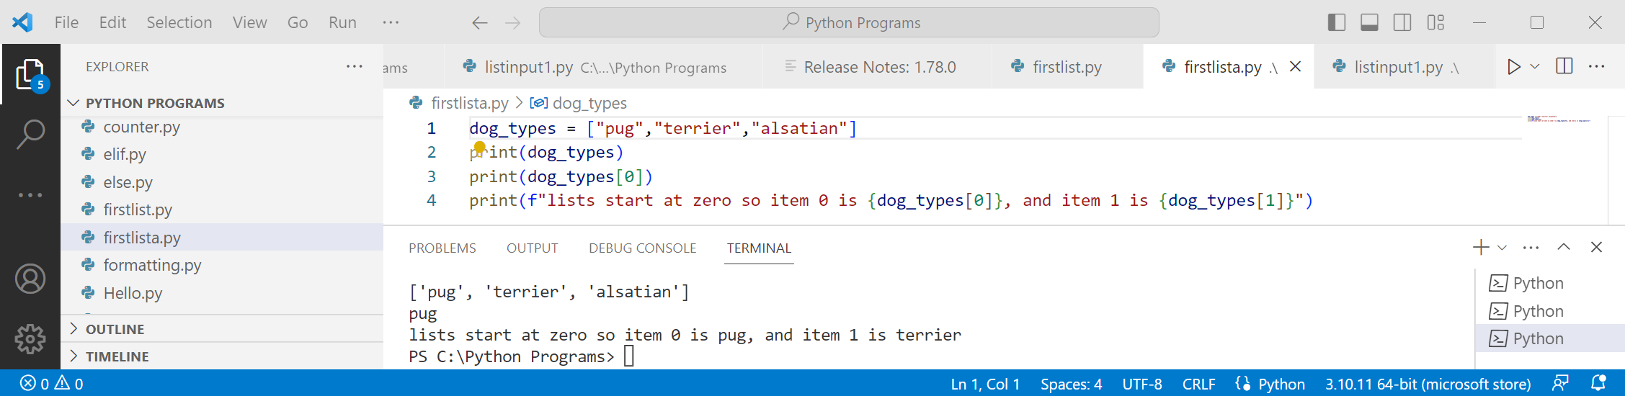

Solution to the task
Modify the program so each item of the list
Add the list number before the item i.e. 0 1 2
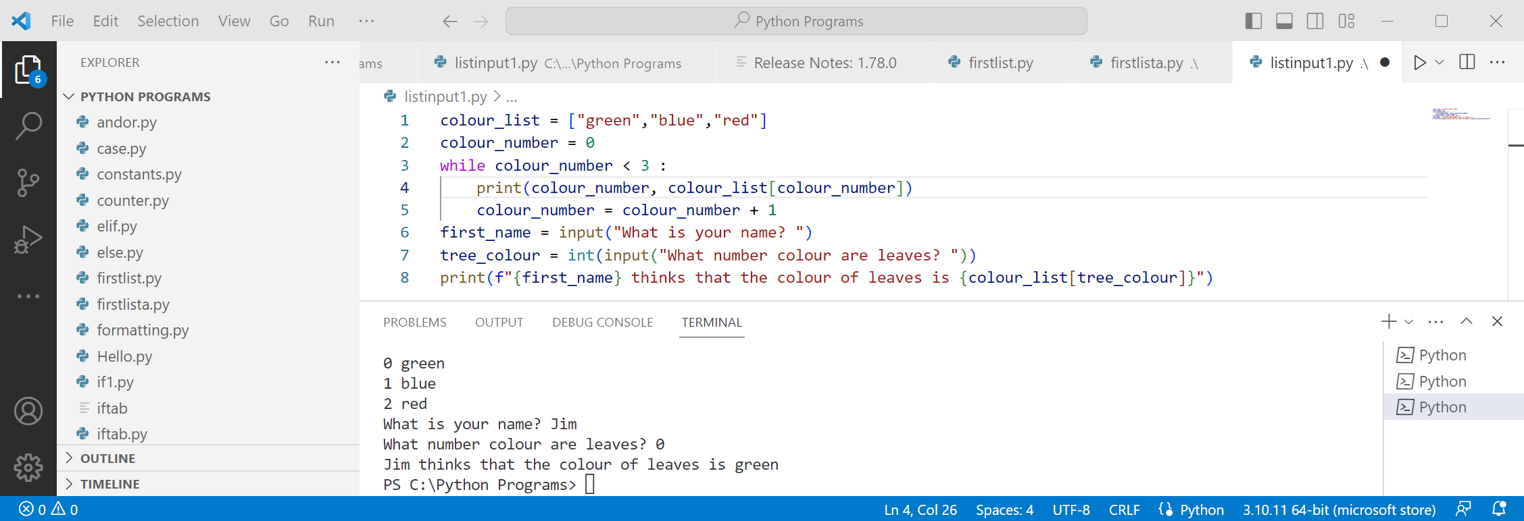
We have used a while loop to print all the items in the list
The variable colour_list prints the number of the item AND to loop the correct number of times

Fixing a potential issue
Having the number “3” in the while statement is a potential issue
If the number we put in is too big we will get an error, if too small we will miss items from the list
To fix this we can use len to find out how may items in the list
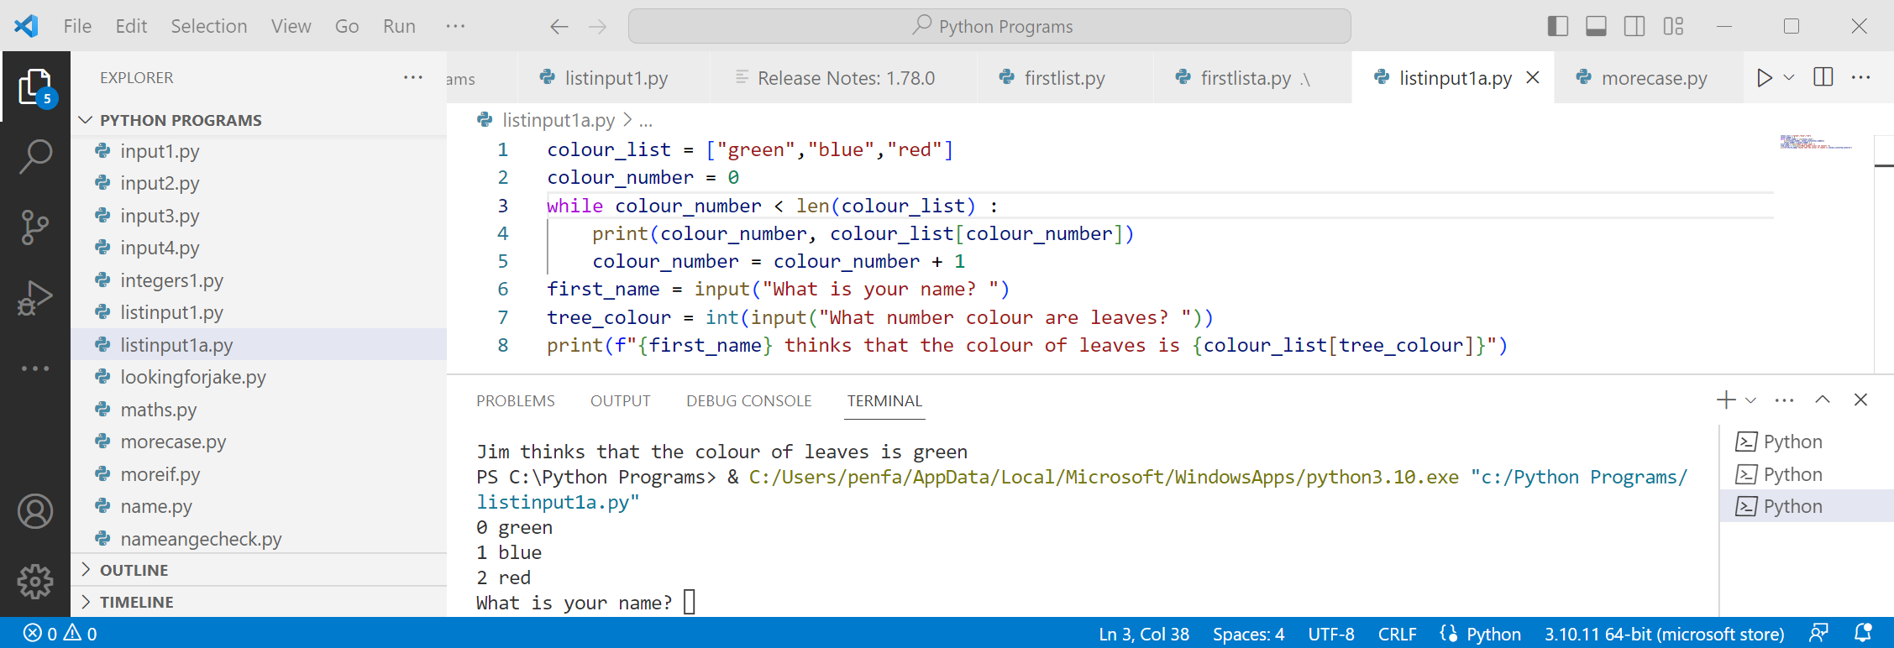
You can see this in the third line of the modified program

Variable naming
When creating a list having _list as the second part of the variable name helps to understand the program
We will often come back to a program later so having sensible variable names helps
Task time
Create a list of prizes people could get
Ask for a number and tell them they have won that prize
This is a sample of what the output might look like
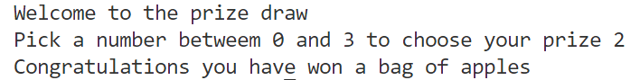

Another type of while loop
We have looked at a number of while loops such as ensuring an answer is input
There are times when we might want the opposite, such as allowing the user to work out the number of inputs
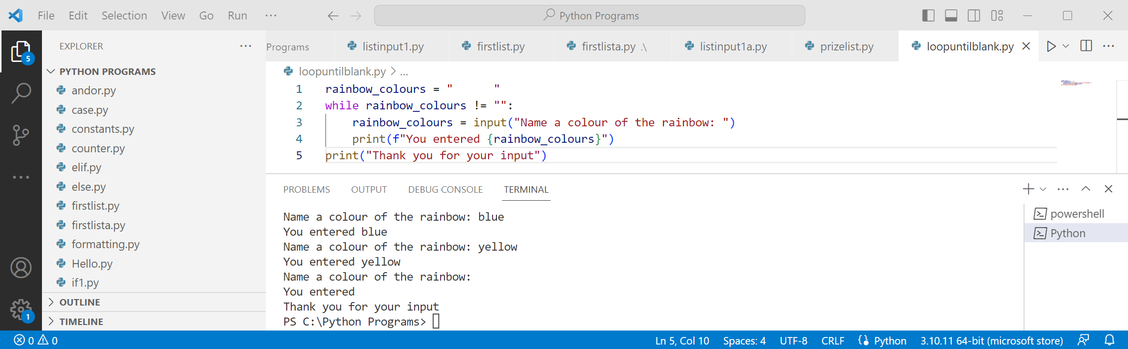
You can see on line 1 the variable is created with a number of spaces. Anything will do except “”
The program is not perfect - an unnecessary you entered is seen near the end

Empty lists
We can create an empty list by creating a variable and making it equal to []
Using an input statement we can then add to the list
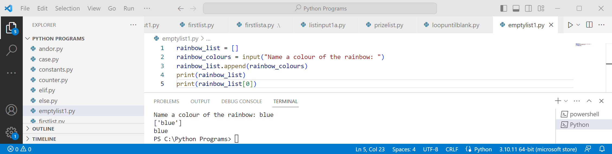
We use .append() to add to the list. This can be repeated as often as needed
Task time
Combine the last two programs so the rainbow colours get added to the list
Fix the problem in the first program where it prints the extra “you entered”

Solution to the task
Create a list of prizes people could get
Ask for a number and tell them they have won that prize
This is a sample of what the output might look like
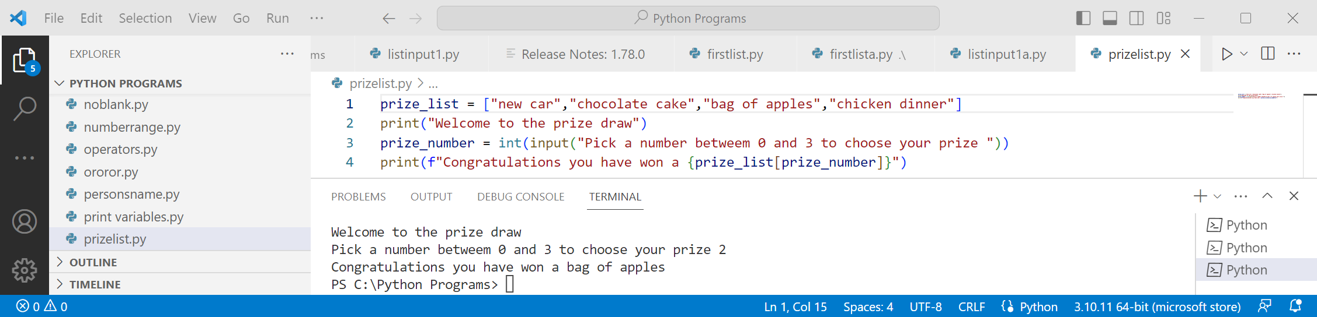
This program has no checking that a valid input is entered – did your program?

Solution to the task
Combine the last two programs so the rainbow colours get added to the list
Fix the problem in the first program where it prints the extra “you entered”
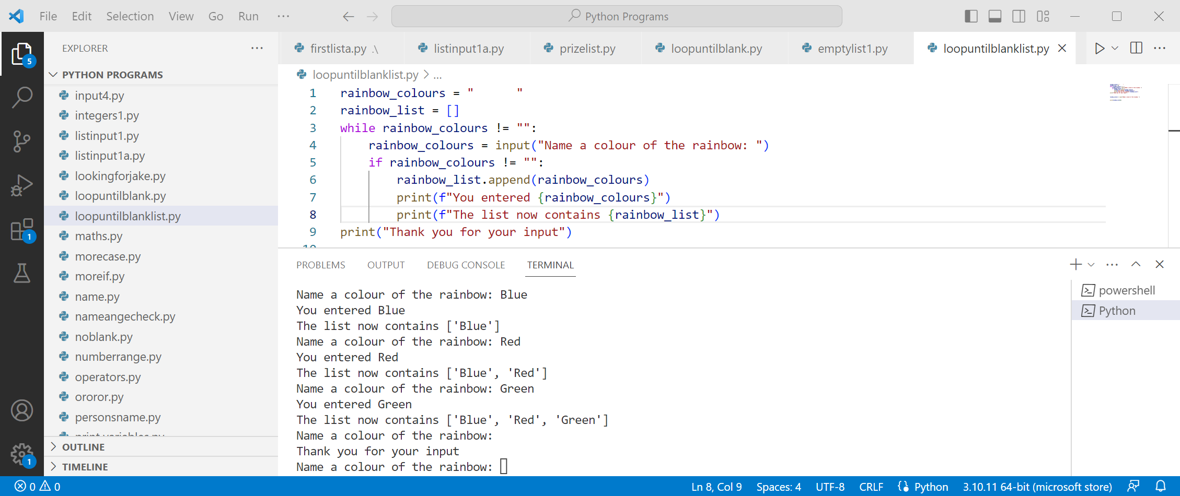
We needed to have a nested if to stop the program from adding and printing the none entry

Using break
We can use break after an if statement to get out of a loop - no other code in the loop are executes
Note how we changed != to == due to the reversal of logic
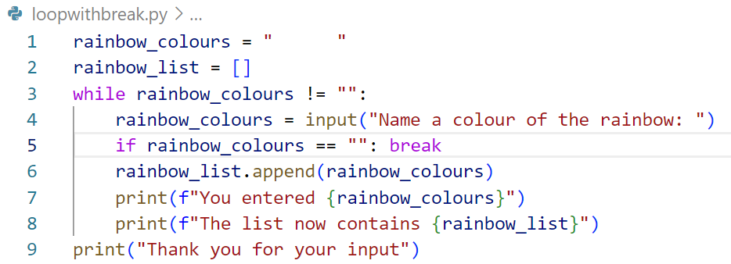

Additional exercises

Exercise 1 – Basic Lists
Create a list of types of flowers
Print off list in full then each one in turn
Extension: put the number in the list before each flower
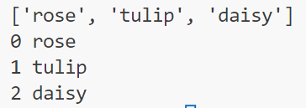

Exercise 2 – Input List
Ask for a number of cat names - stop and print them off when enter pressed
Extension: don’t add a blank item at the end
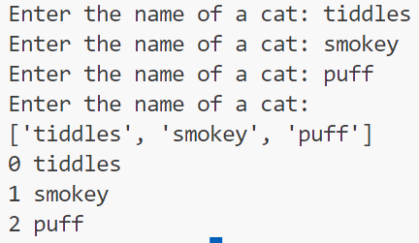

Looping a number of times
Instead of looping until a blank is entered, we can just ask for a certain number of inputs
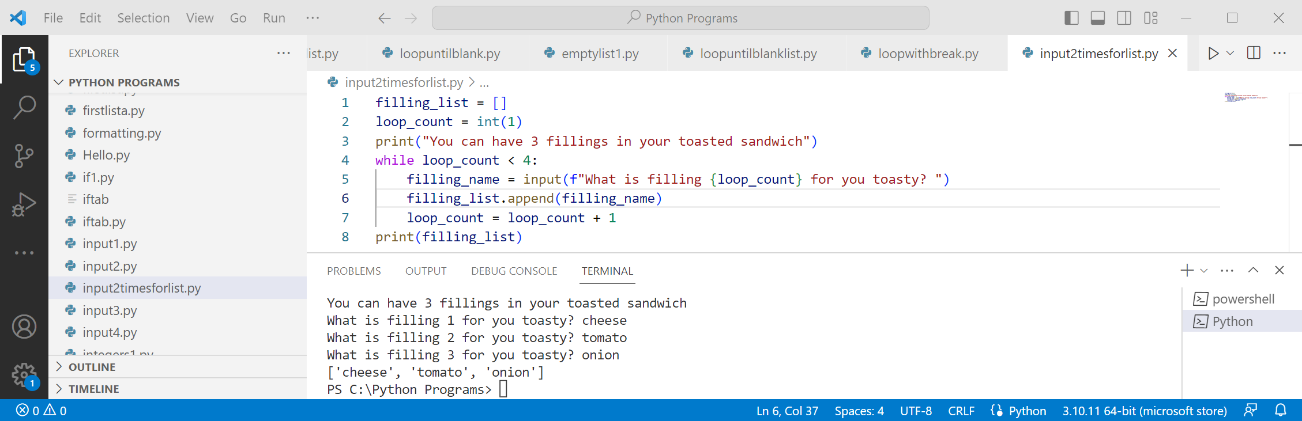
We always need to be aware that how the program is seen is different to how actually works
We are asking for filling number “1” but this is stored in the list as item “0”
Task time
Add extra code so the names of the fillings are printed in a single line as shown below

Combining two loops
We will often want to use a loop to build a list, then another to print the contents
This has already been done - just not combined together
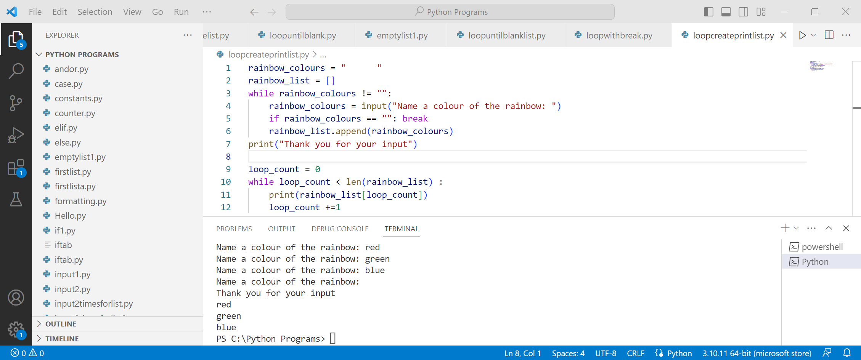
A blank line has been used to separate the parts of the code
The line loop_count = 0 has been put at line 9 - it should normally be at the start of the program
Note the use of +=1 to increment the loop
Task time
Print all the colours on one line
Hint: use end = “”

Deleting items from a list
There are two methods of deleting items from a list
By using remove you can specify the text of the item such as blue
If you don’t spell it correctly you will get an error as the item cannot be found
By using pop you specify the index number in the list
Each time you pop an item in the list the index changes, so you can delete item 1 multiple times
If you specify an index number that does not exist, you will get an error
With both remove and pop you can check to see if the item exists, or use try and except
Task time
Modify the toasted sandwich program so bread and butter are already on the list
Print out the list with all the items including bread and butter

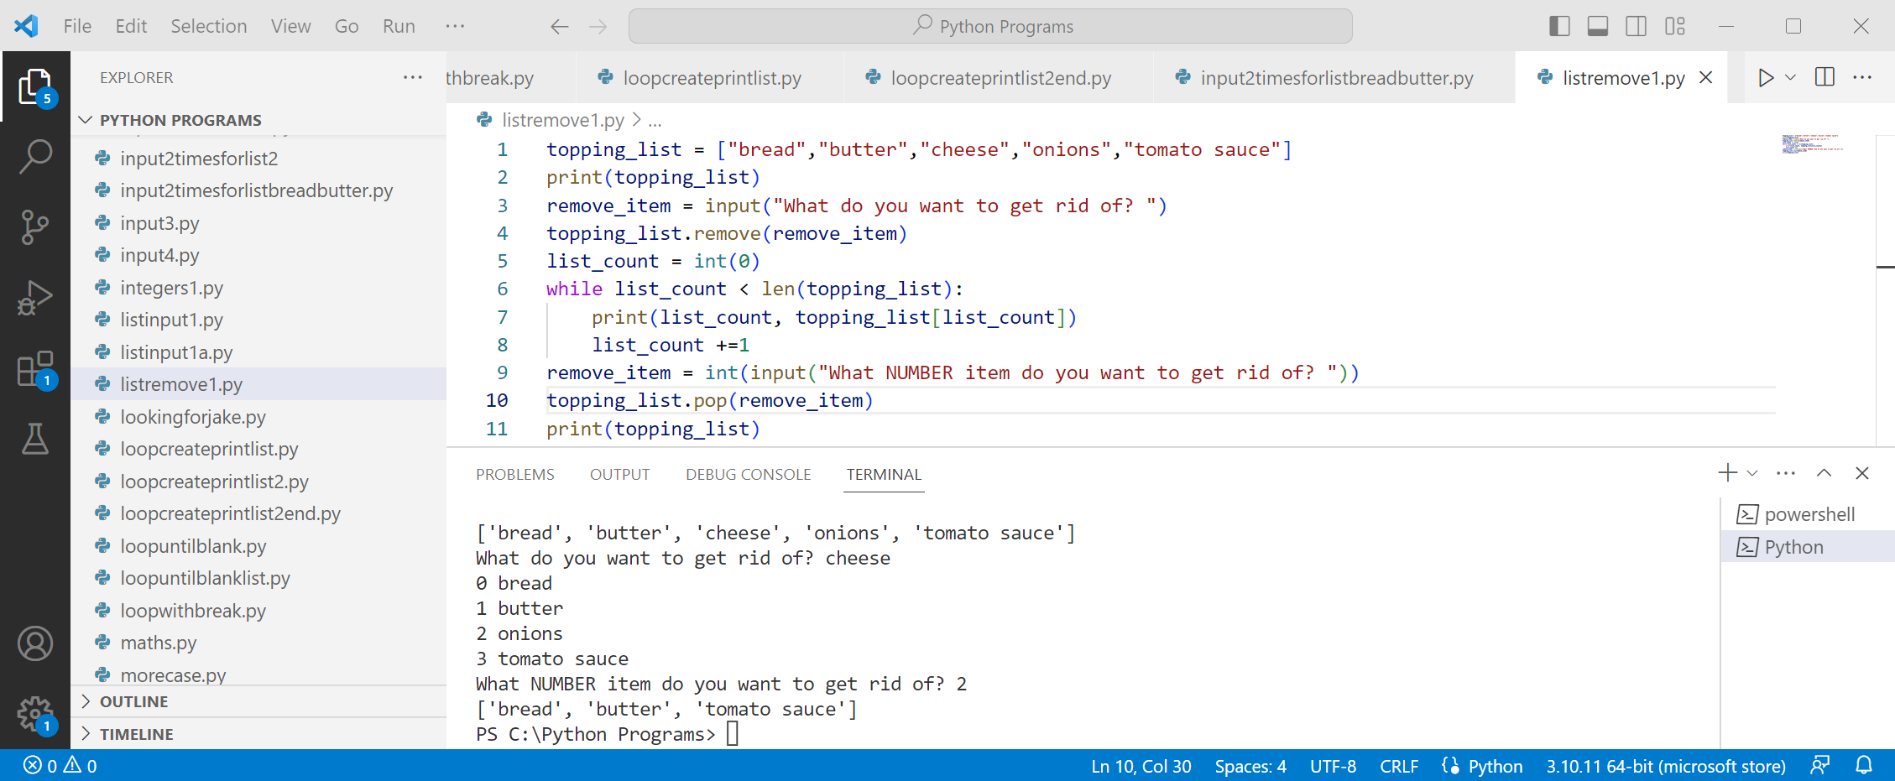
Solution to the task
Modify the toasted sandwich program so bread and butter are already on the list
Print out the list with all the items including bread and butter
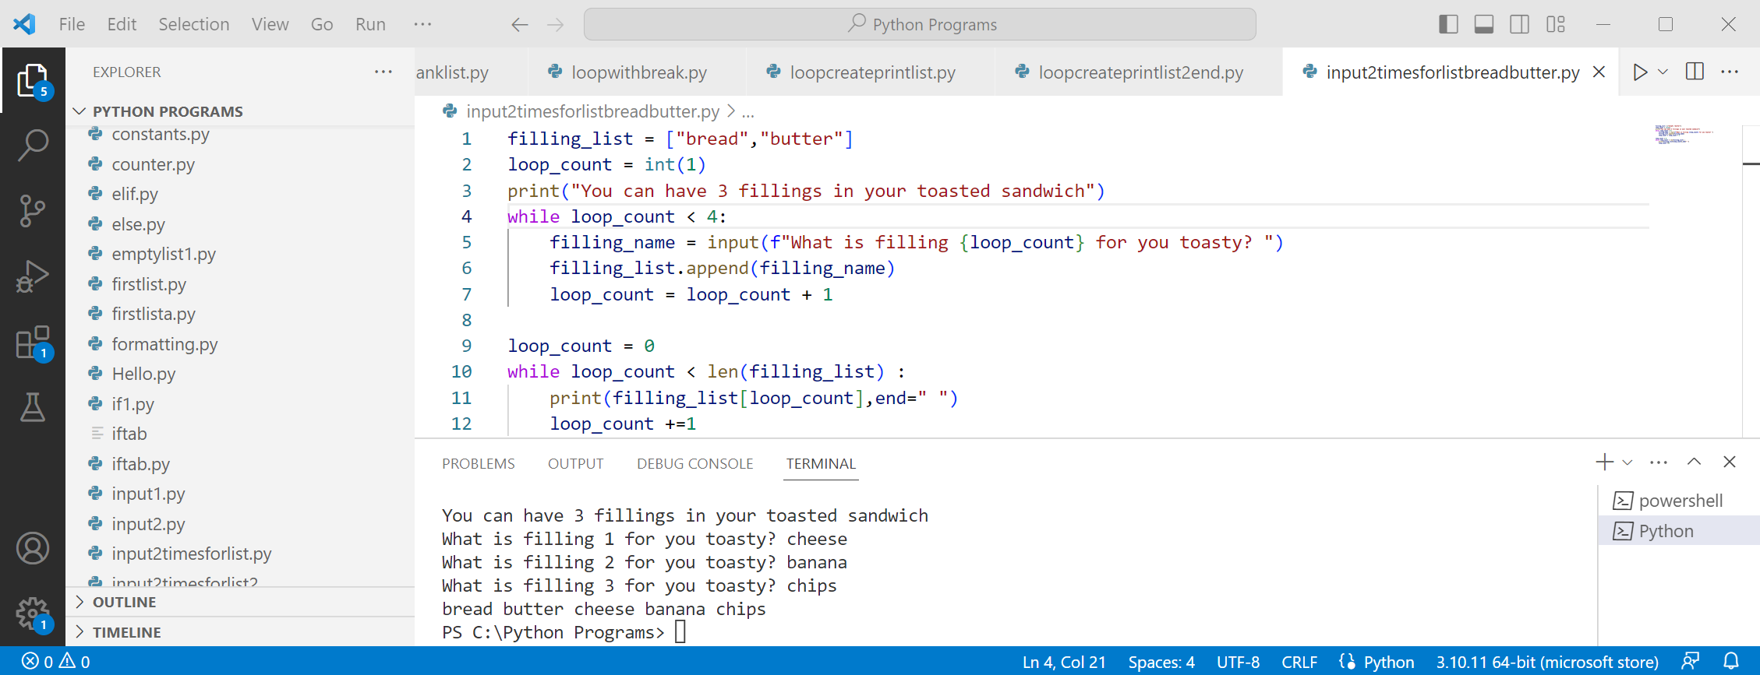
If you changed the program to allow unlimited fillings, that is good also
It is also okay if you printed the fillings in a single line

Working with subroutines

Introduction
We will be returning to lists in a bit, but first we need to understand subroutines
A subroutine allows you to divide your program into sections, each doing a particular thing
Each subroutine starts with def() followed by the name of the subroutine such as def inputs():
Nothing goes in the brackets – we will start putting things in them next year
Each subroutine is tabbed in - this means while statements etc. are tabbed in twice
First, we create the subroutines, then we run them. You can’t run a subroutine you haven’t created
We run each subroutine by putting its name on a line
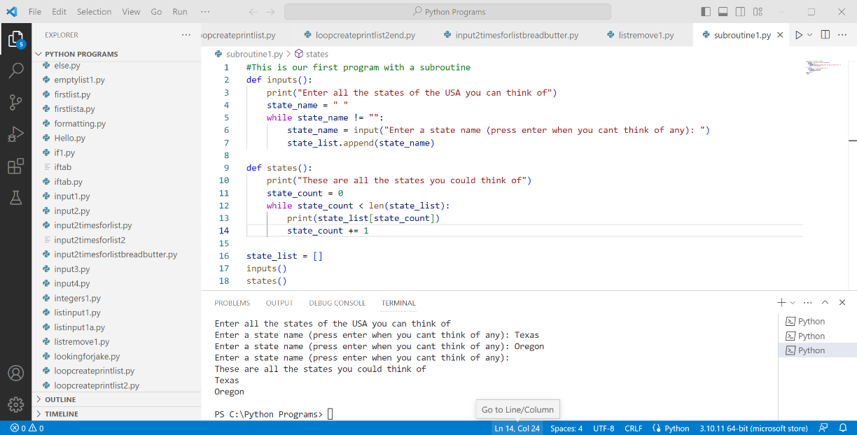

Variables and subroutines
Variables are unique to each subroutine
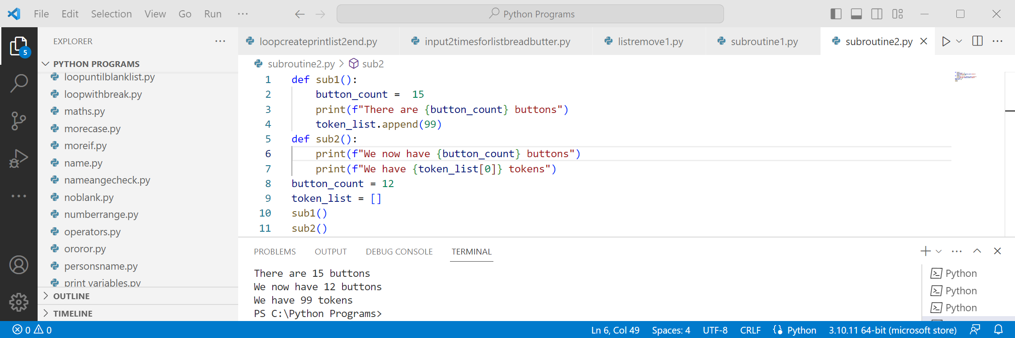
Study this program and you will see that you can appear to change a variable, but this is not the case
Instead, we have two versions of button_count One that exists outside the subroutine and one in the subroutine
At the stage of learning programming,we are currently at, you should avoid duplicating variable names
However, we created token_list outside a subroutine, modified it in a subroutine and accessed it in a different subroutine. This only works if the list is created outside of subroutines
There is a thing called a global variable, however, NZQA considers them to be bad coding practice and does not accept them for any grade greater than Achieved, so we will NOT be covering them in these notes
Task time
Create a program that asks for a person’s name in one subroutine and saves it to a list
In a separate subroutine print the name of the person

In these examples we have only used very simple programs, - they would normally be more involved

Solution to the task
Create a program that asks for a person’s name in one subroutine and saves it to a list
In a separate subroutine print the name of the person
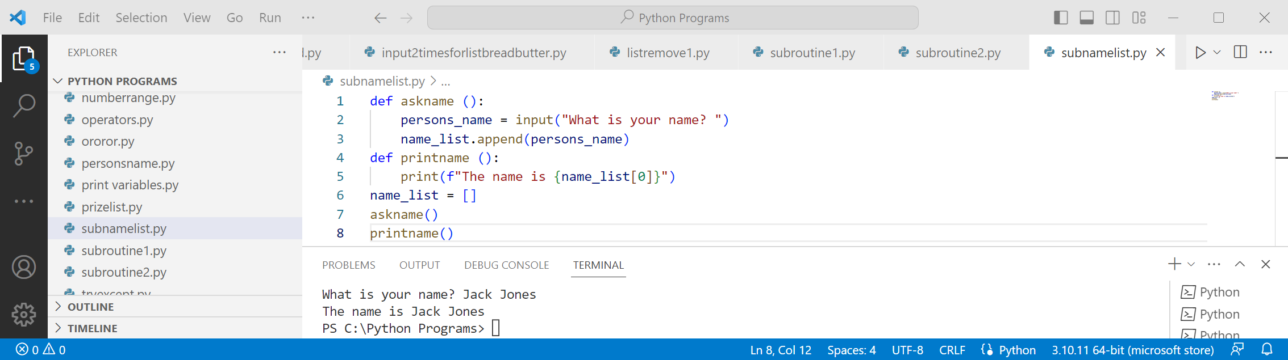
Try moving name_list = [] into the subroutine, you will see the program fails

Tuples
We have looked at lists as a way of storing collections of data in one place - tuples are next
Lists are well suited when you are storing similar things like colours together
Tuples are well suited when storing items that are NOT similar
This does not mean you can’t save dissimilar things in a list or similar things in a tuple, just that they are best suited that way around
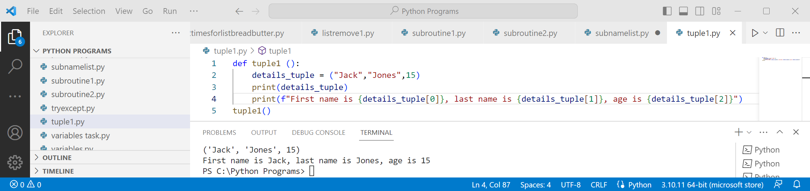
Note how tuples use round brackets instead of square brackets
Task time
Modify the tuple to add in their year level at school

Combining multiple types of data
When could use two lists to combine data
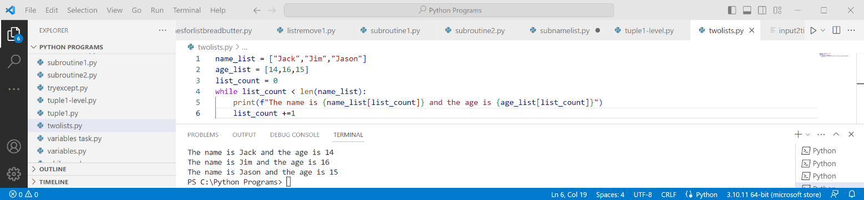
Solution to the task
Modify the tuple to add in their year level at school
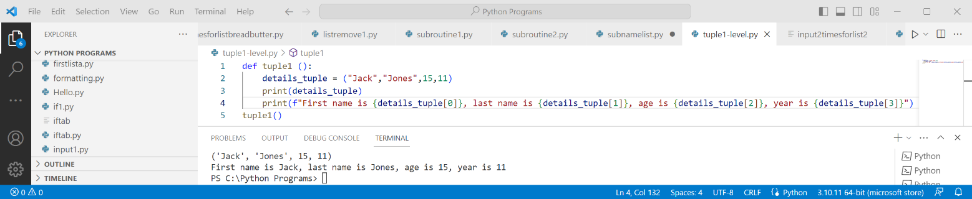

Or we could have a list with two types of data
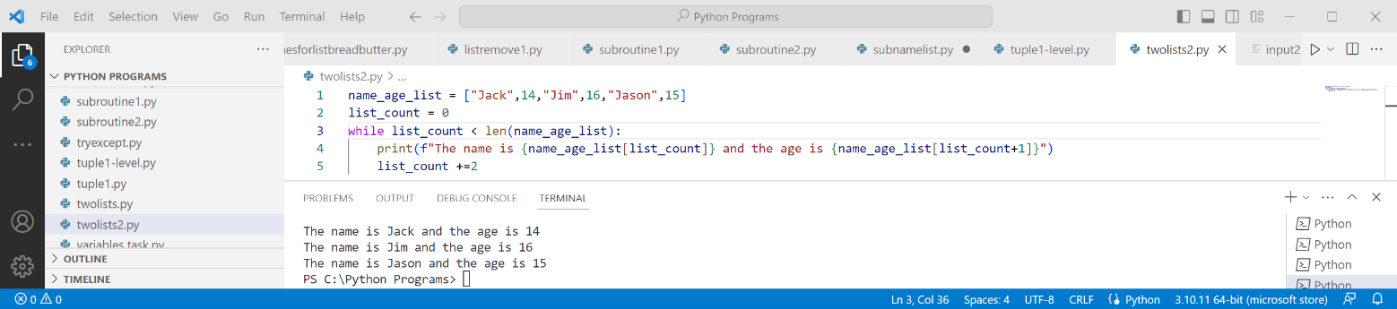
A better way is to combine lists and tuples
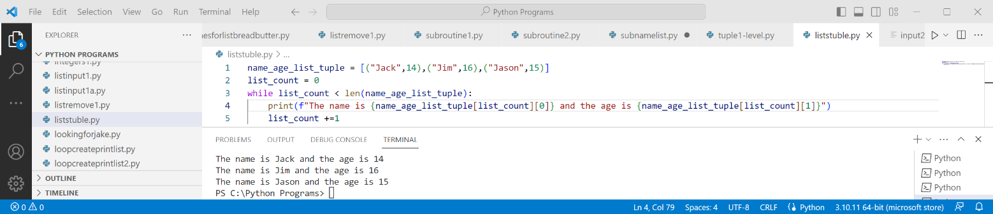
You can see that all three methods work and give the same result
At level 1 all three methods are acceptable
However, as we move to level 2 and 3, only combining lists and tuples will be the simplest approach
Task time
We only have first name and age. Add middle name, last name and class name
You can use any of the three methods shown, but only the answer for lists/tuples is given

Solution to the task
We only have first name and age. Add middle name, last name and class name
You can use any of the three methods shown, but only the answer for lists/tuples is given
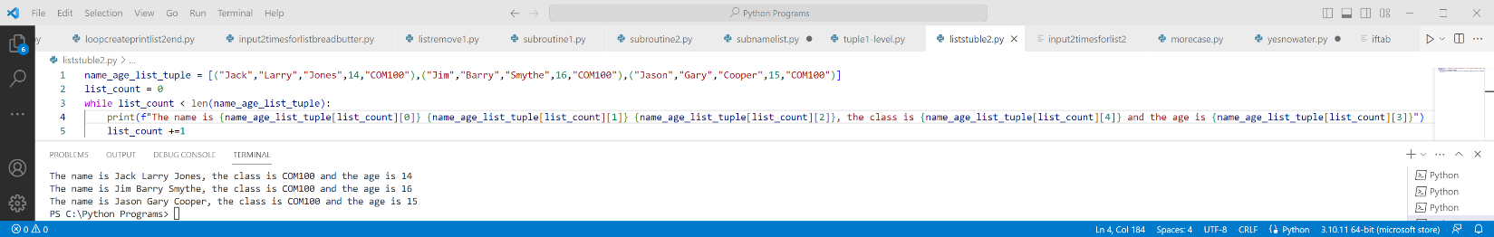

Side topic – splitting lines of code
In the above example the line is very long and there are times you may need to split it
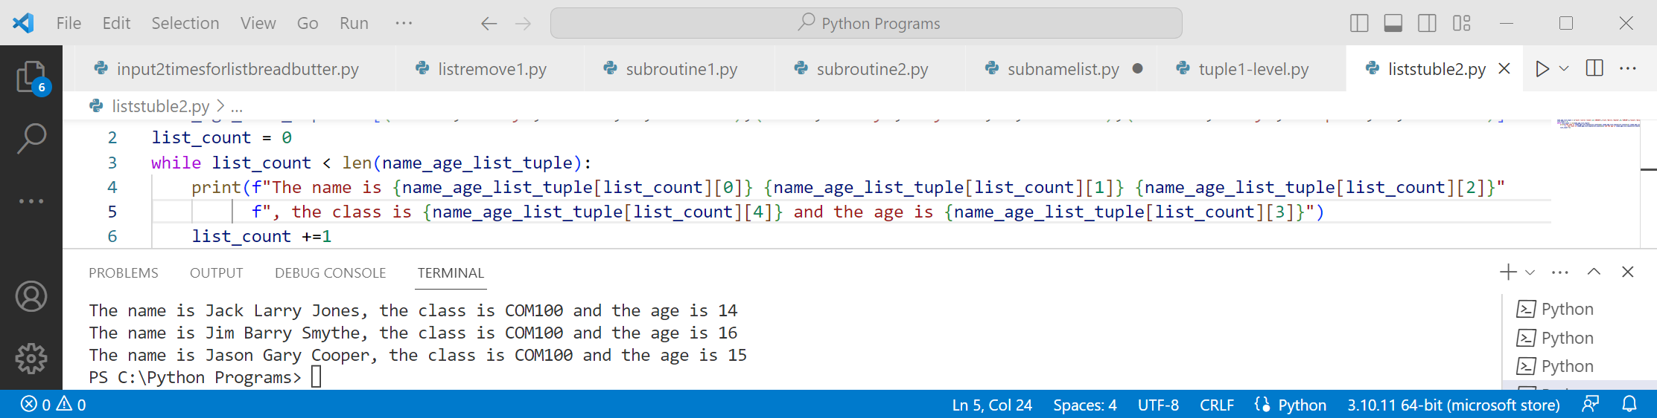
You can see above, when using f in a print you close the quotes, but not the brackets, and put a second f on the next line. You can repeat this as many times as you wish
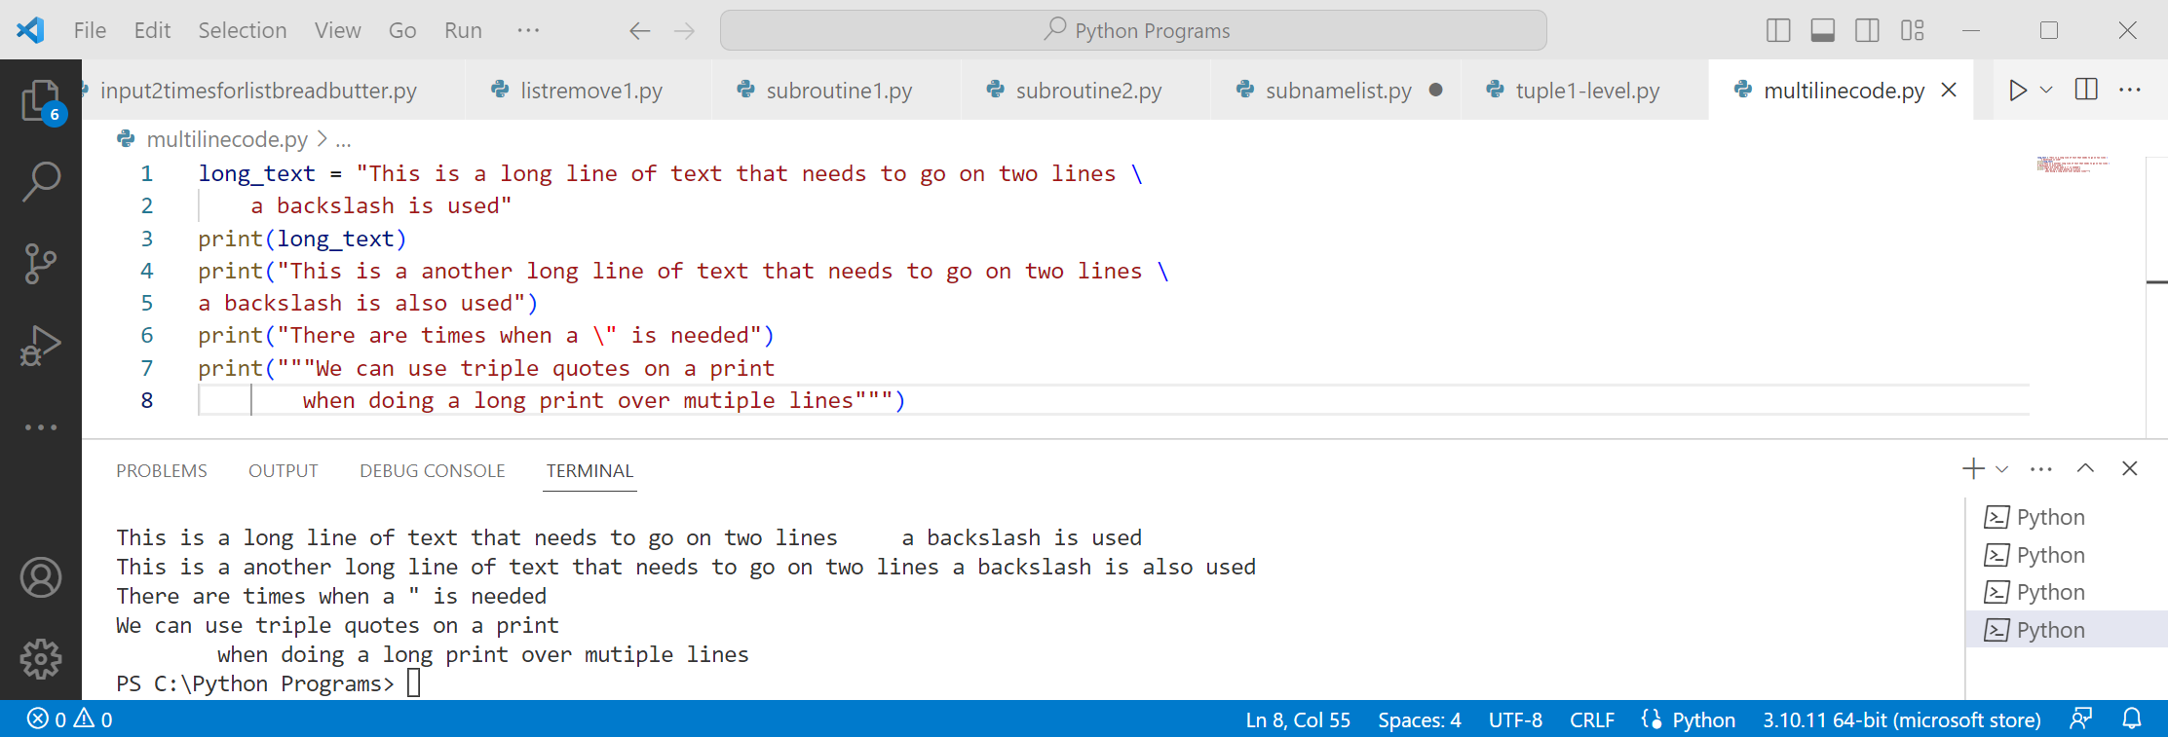
You can also use the backslash for multiple lines
The backslash can also be used when you want a quote to print instead of being a closed quote
Using triple quotes lets you put in multiple lines of output - it also prints out on multiple lines
However, take care there are no unwanted spaces or tabs in the output

Tuples
We have looked at lists as a way of storing collections of data in one place - tuples are next
Lists are well suited when you are storing similar things like colours together
Tuples are well suited when storing items that are NOT similar
This does not mean you can’t save dissimilar things in a list or similar things in a tuple, just that they are best suited that way around

Note how tuples use round brackets instead of square brackets
Task time
Modify the tuple to add in their year level at school

Combining multiple types of data
When could use two lists to combine data

Solution to the task
Modify the tuple to add in their year level at school


Or we could have a list with two types of data

A better way is to combine lists and tuples

You can see that all three methods work and give the same result
At level 1 all three methods are acceptable
However, as we move to level 2 and 3, only combining lists and tuples will be the simplest approach
Task time
We only have first name and age. Add middle name, last name and class name
You can use any of the three methods shown, but only the answer for lists/tuples is given

Solution to the task
We only have first name and age. Add middle name, last name and class name
You can use any of the three methods shown, but only the answer for lists/tuples is given


Side topic – splitting lines of code
In the above example the line is very long and there are times you may need to split it

You can see above, when using f in a print you close the quotes, but not the brackets, and put a second f on the next line. You can repeat this as many times as you wish

You can also use the backslash for multiple lines
The backslash can also be used when you want a quote to print instead of being a closed quote
Using triple quotes lets you put in multiple lines of output - it also prints out on multiple lines
However, take care there are no unwanted spaces or tabs in the output

Dictionaries
The dictionary is the final method of storing data in collections
Unlike lists and tuples which work well together, dictionaries are generally used by themselves
In a traditional dictionary we look up a word and it tells us a meaning
In Python dictionaries are similar - we look up a word and it gives us something stored there
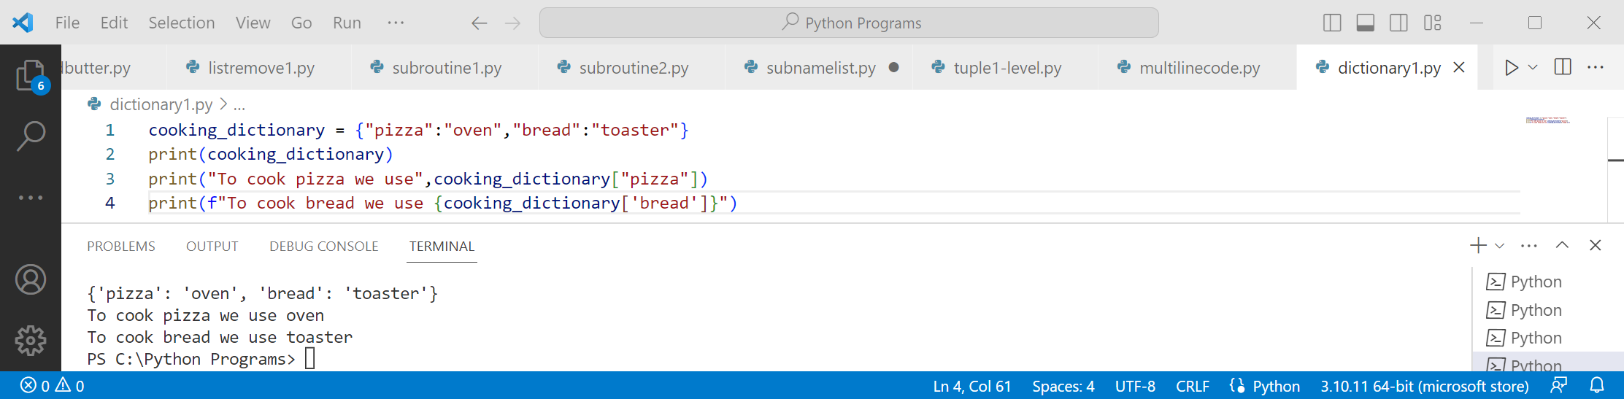
We have been using f to format our print statements. Unfortunately printing dictionary items using f is quite complicated. You need to add braces around the dictionary name and use single quotes
Task time
Add two more food items and methods of cooking them
For the first print swap the quotes to single quotes are used after the f and double quotes in the dictionary
For the second print create a variable with the cooking method and print that instead
Create a subroutine with the code in. Leave the dictionary out of the subroutine

Changing dictionary values
To create a dictionary we use braces - to change an item we use square brackets
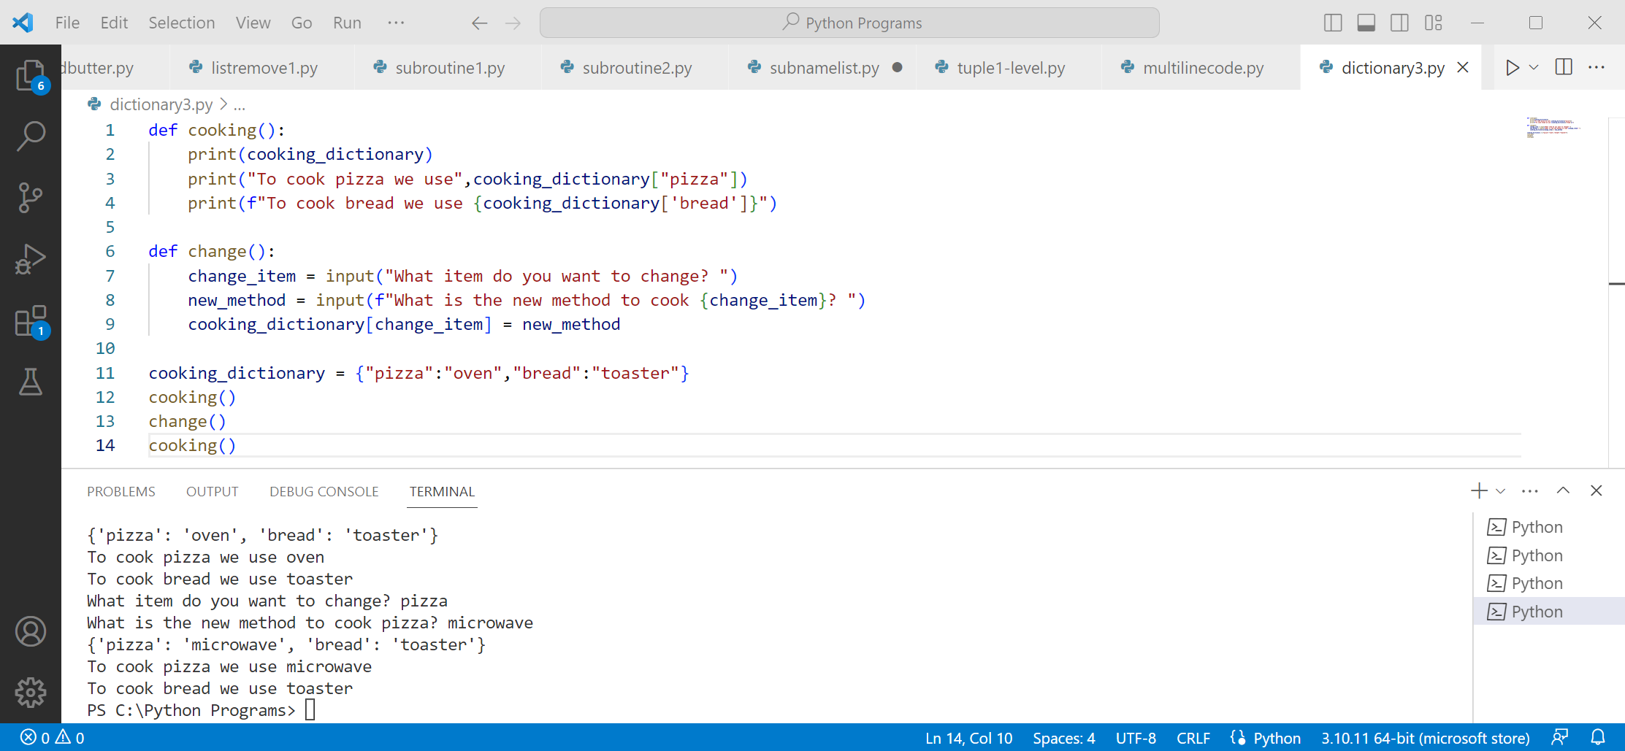
You can see the item to be changed in square brackets with the new value after the equals sign
Also, note how the change in one subroutine is shown in a different subroutine
Note how the grammar is not quite right - not a task but feel free to improve it!
Solution to the task
Add two more food items and methods of cooking them
For the first print swap the quotes to single quotes are used after the f and double quotes in the dictionary
For the second print create a variable with the cooking method and print that instead
Create a subroutine with the code in. Leave the dictionary out of the subroutine
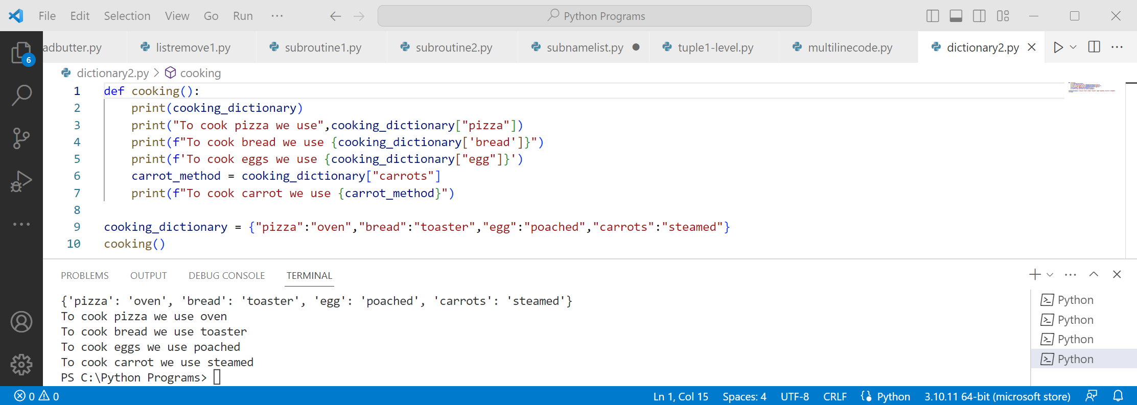
Your items are most likely different - any suitable it is okay

